AN ONLINE JOB PORTAL
A platform for connecting employers and job seekers in Uganda

A PROJECT REPORT SUBMITTED TO THE FACULTY OF SCIENCE FOR THE STUDY LEADING TO THE PARTIAL FULLFILMENT OF THE REQUIREMENTS FOR GRADUATION WITH A BACHELORS DEGREE IN INFORMATION TECHNOLOGY AT UGANDA MARTYRS UNIVERSITY.

PREPARED BY:
AYEBARE MARK GENERAL
BSC. INFORMATION TECHNOLOGY
REG NO. 2022-B071-10283

ABSTRACT
This dissertation investigates the design, development, and evaluation of an online job portal tailored to address unemployment and recruitment inefficiencies in Uganda. The platform aims to enhance accessibility, efficiency, and inclusivity for both job seekers and employers by addressing challenges such as fragmented job search platforms, repetitive application processes, and difficulties in sourcing qualified candidates. The study employs a mixed-methods approach, combining quantitative surveys and qualitative interviews, to assess usability, user satisfaction, and the system's impact on job placement rates. Developed using Agile and Iterative Methodology, the portal incorporates features like user registration, job posting and search, personalized recommendations, an Applicant Tracking System (ATS), and secure messaging. Usability testing and stakeholder feedback reveal high user satisfaction, with participants praising the intuitive interface and streamlined processes. The platform demonstrates potential to reduce unemployment and promote economic growth, aligning with the United Nations' Sustainable Development Goal (SDG) 8 on decent work and economic growth.

Despite its successes, the study identifies challenges such as limited internet access in rural areas and low digital literacy among some users, which hinder widespread adoption. To mitigate these issues, offline functionalities and simplified interfaces were introduced, alongside partnerships with community centers and educational institutions to provide training and support. The research contributes to academic knowledge and practical solutions by showcasing the transformative potential of technology-driven platforms in addressing labor market inefficiencies in developing countries. It also provides actionable recommendations for future improvements, including developing a mobile application, integrating payment systems, and implementing advanced AI-driven matching algorithms. By offering a scalable and sustainable solution, this study underscores the role of digital innovation in fostering socio-economic growth and reducing unemployment in Uganda.

.

ACKNOWLEDGEMENTS
I sincerely thank my supervisor, Mr. George William Kasaazi, for their invaluable guidance and support throughout this project. I am also thankful to my family, friends, and colleagues for their encouragement and helpful feedback. A special appreciation goes to the participants who generously shared their time and insights during the evaluation phase. Lastly, I acknowledge the resources and infrastructure provided by Uganda Martyrs University, which made this research possible

TABLE OF CONTENTS
Contents
CHAPTER 1: INTRODUCTION 8
1.1 Background of the Study 8
1.2 Problem Statement 9
1.3 Research Objectives 10
1.4 Research Questions 10
1.5 Significance of the Study 10
1.6 Scope of the Study 12
1.7 Definition of Terms 13
1.8 Conclusion 14
CHAPTER 2: LITERATURE REVIEW 15
2.1 Introduction 15
2.2 Theoretical Framework 15
2.3 Review of Previous Research on Online Job Portals 16
2.4 The Labor Market in Uganda and Sub-Saharan Africa 17
2.4.1 Overview of Employment Landscape 18
2.4.2 Challenges in Job Search and Recruitment 19
2.4.3 Role of Technology in Economic Development 21
2.4.4 Existing Online Recruitment Platforms in Uganda 23
2.5 Synthesis of Literature and Research Gap 24
2.6 Conclusion 26
CHAPTER 3: RESEARCH METHODOLOGY 27
3.0 Introduction 27
3.1 Research Design 27
3.2 Study Area 27
3.3 Population 27
3.4 Sampling Technique 27
3.5 Sample Size 28
3.6 Data Collection Methods 28
3.7 System Activities and Design 28
3.8 System Implementation 29
3.9 System Testing and Validation 29
3.10 Maintenance 29
3.11 Ethical Considerations 30
3.12 Conclusion 30
CHAPTER 4: SYSTEM DESIGN AND IMPLEMENTATION 31
4.0 Description of the System 31
4.1 The System Overview 31
4.2 Data Analysis 31
Quantitative Analysis 31
Qualitative Analysis 32
4.3 User Requirements 32
Functional Requirements 32
Non-Functional Requirements 32
4.4 Hardware and Software Requirements for the Proposed System 33
Hardware Requirements 33
Software Requirements 33
4.5 System Architecture 33
4.6 Database Design 33
4.7 User Interface (UI) and User Experience (UX) Design 36
4.8 Front-End Development 36
4.9 Back-End Development 38
4.10 Security Implementation 39
4.11 System Implementation, Testing, and Validation 39
4.12 User Registration Diagram 40
4.13 Context Diagrams 41
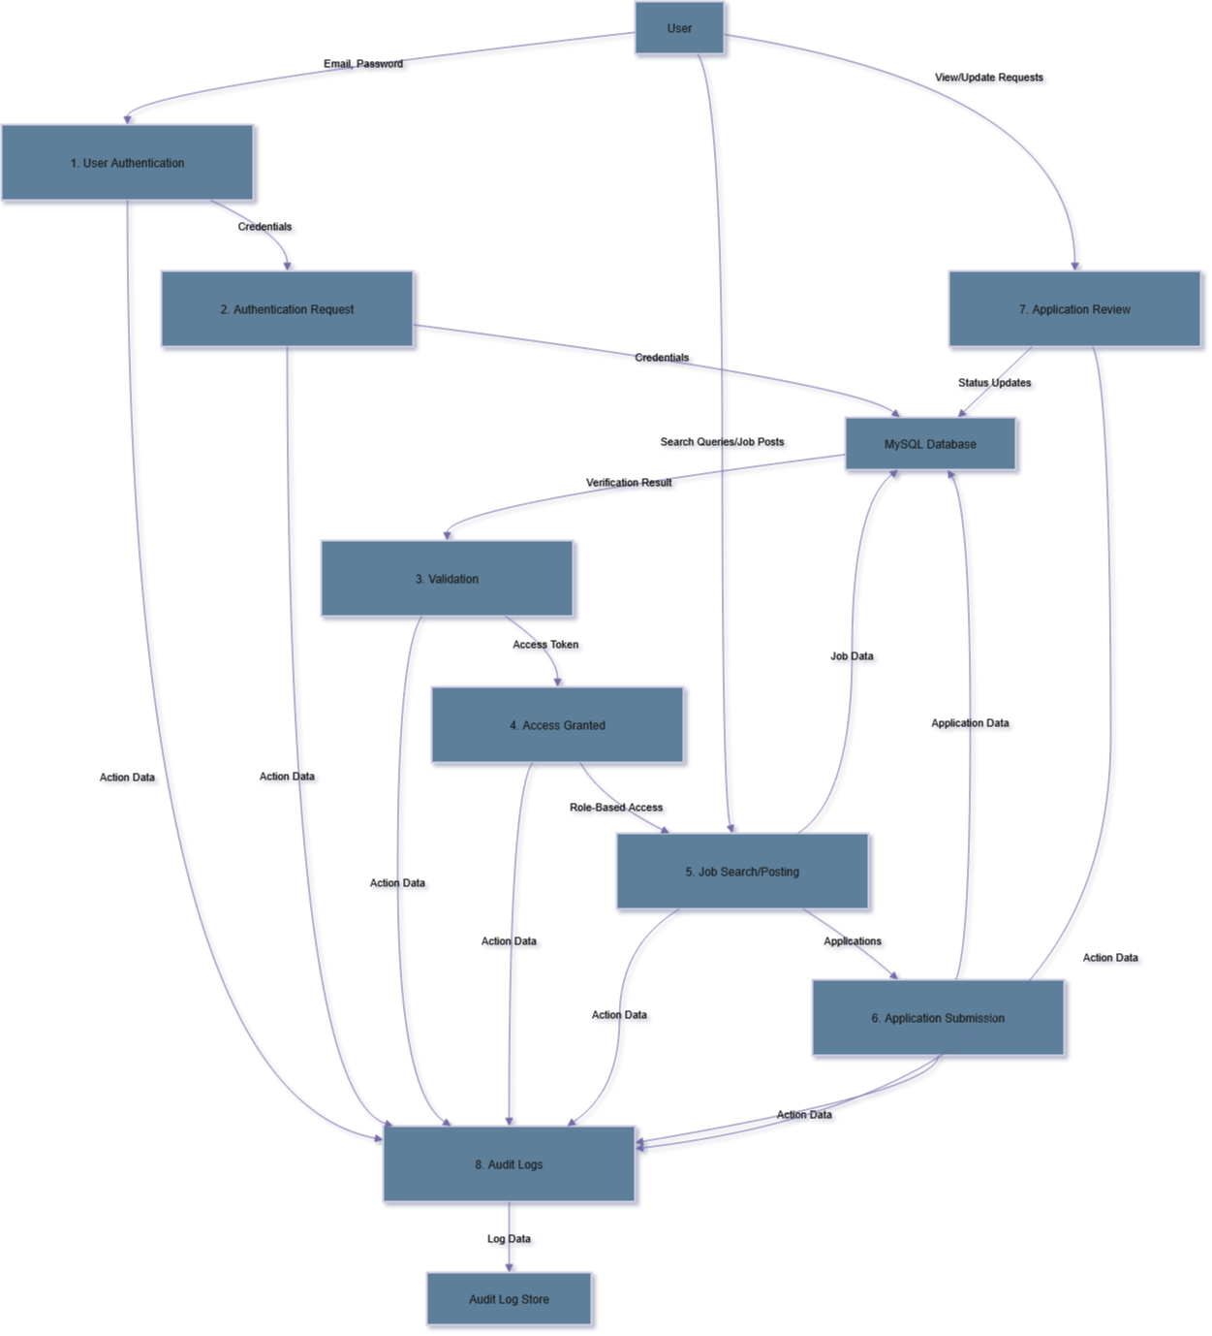 41
4.14 Sequence Diagram 41
4.15 Conclusion 42
CHAPTER 5: DISCUSSION 43
5.0 Introduction 43
5.1 Interpretation of Findings 43
5.2 Comparison with Existing Literature 43
5.3 Implications for System Design 44
5.4 Challenges and Mitigation Strategies 44
5.5 Implications of Findings and study 44
5.7 Limitations of the Study 45
5.8 Conclusion 45
CHAPTER 6: CONCLUSION AND RECOMMENDATIONS 47
6.0 Introduction 47
6.1 Conclusions 47
6.2 Recommendations 48
6.3 Areas for Future Research 49
6.4 Conclusion 49
REFERENCES 50
APPENDICES

CHAPTER 1: INTRODUCTION

1.1 Background of the Study
The global transition towards digital platforms has fundamentally transformed the way individuals search for employment and how employers recruit talent. Traditional methods of job searching, such as newspaper advertisements, in-person job fairs, and word-of-mouth referrals, are increasingly becoming outdated due to their inefficiency, limited reach, and inability to meet contemporary user demands (Smith & Anderson, 2020; Kumar et al., 2023). These conventional strategies often result in disjointed platforms where job seekers struggle to find relevant opportunities, while employers face challenges in efficiently identifying qualified candidates (Uganda Bureau of Statistics, 2022).
Conversely, online job portals have become a fundamental component of modern recruitment processes, providing centralized solutions that effortlessly connect job seekers and employers. These platforms utilize advanced technologies such as machine learning algorithms for personalized job recommendations, cloud-based databases for storing job listings, and secure communication channels to facilitate interactions between stakeholders (International Telecommunication Union [ITU], 2022). For example, platforms like LinkedIn employ sophisticated algorithms to align job seekers with appropriate opportunities based on their skills, experience, and preferences (Smith & Anderson, 2020). Similarly, tools such as Applicant Tracking Systems (ATS) allow employers to efficiently manage large volumes of applications, thereby reducing the time needed to identify suitable candidates (Johnson & Williams, 2021).
Despite these innovations, many existing job portals do not adequately address the distinct challenges faced by users in developing regions such as Uganda. Job seekers in rural areas often experience obstacles such as limited internet access and low digital literacy, which impede their ability to effectively utilize online platforms (World Bank, 2021). According to the Uganda Bureau of Statistics (2022), high youth unemployment rates and inefficient recruitment processes further aggravate the situation, leaving many individuals unable to transition from education to employment. Small and medium-sized enterprises (SMEs) in Uganda also encounter considerable challenges in expanding their operations due to difficulties in recruiting skilled workers (Kumar et al., 2023).
This final-year project aims to develop an online job portal web application specifically designed to address these challenges by offering a comprehensive platform where employers can post job opportunities and job seekers can apply directly. The proposed system will incorporate features such as personalized job recommendations, advanced search filters, secure communication channels, and an applicant tracking system (ATS). By leveraging modern technologies and user-focused design principles, the platform aspires to revolutionize the recruitment landscape in Uganda, aligning with global trends in digital transformation and human resource management (HRM) practices (Kumar et al., 2023).
Additionally, this initiative aligns with the United Nations Sustainable Development Goal (SDG) 8, which emphasizes promoting decent work and economic growth (United Nations, 2023). By enhancing access to employment opportunities and improving the efficiency of recruitment processes, the online job portal holds the potential to significantly contribute to reducing unemployment and fostering economic development in Uganda. For instance, a platform that connects unemployed youth with SMEs in need of skilled labor could help address the country's high youth unemployment rate, reported at 13.3% by the Uganda Bureau of Statistics (2022).

1.2 Problem Statement
The labor market in Uganda faces significant challenges that create obstacles for both job seekers and employers, leading to increased levels of unemployment and underemployment while also impeding business growth. These challenges stem from systemic issues like fragmented platforms, limited access to technology, and a lack of tailored solutions that meet the unique needs of Ugandan users.
- Challenges Faced by Job Seekers:
Job seekers in Uganda encounter a variety of difficulties when trying to find employment. One of the most pressing concerns is the challenge of discovering relevant job opportunities due to the absence of unified platforms. Instead, job listings are scattered across multiple channels, such as newspapers, informal networks, and unorganized online forums (Uganda Bureau of Statistics, 2022). This fragmentation forces job seekers to navigate a multitude of sources, considerably increasing the time and effort required to identify suitable positions. Moreover, the existing platforms often lack personalized recommendations, compelling job seekers to manually sift through many inappropriate postings. This not only reduces their chances of securing a job but also leads to frustration and discouragement with the job search process.
Another significant issue is the inefficiency of the application processes. Many platforms ask job seekers to repeatedly upload resumes and cover letters for each job application, resulting in redundant and tedious tasks. According to the World Bank (2021), these inefficiencies disproportionately impact vulnerable groups, such as the youth, rural populations, and individuals with low digital literacy. For example, job seekers in rural areas often face limited internet access, further hindering their ability to effectively use online platforms. These barriers contribute to prolonged periods of unemployment and financial instability, especially among young people, who form a substantial part of Uganda's unemployed populace.
- Challenges Faced by Employers:
Employers in Uganda encounter significant obstacles in the recruitment process, particularly in efficiently reaching qualified candidates. Numerous businesses, especially small and medium-sized enterprises (SMEs), face challenges in attracting skilled workers due to the lack of centralized platforms and effective tools for application management (Kumar et al., 2023). SMEs, a vital component of Uganda's economy, often lack the necessary resources to broadly advertise job openings or employ advanced recruitment technologies. Consequently, their inability to connect with a wider pool of talent impairs their capacity to expand and innovate.
Furthermore, the manual evaluation of applications and the scheduling of interviews represent substantial bottlenecks in the recruitment process. In the absence of automated tools like Applicant Tracking Systems (ATS), employers must dedicate considerable time to reviewing resumes, shortlisting candidates, and coordinating interviews. This inefficiency not only prolongs the hiring process but also increases the risk of losing top talent to competitors. According to Johnson and Williams (2021), these challenges are further exacerbated by the lack of secure communication channels, which can lead to miscommunication or fraudulent activities during the recruitment process.
The inefficiencies within Uganda's labor market have extensive implications for the country's socio-economic development. High unemployment rates, estimated at 13.3% among youth, contribute to poverty, civil unrest, and diminished productivity (Uganda Bureau of Statistics, 2022). For businesses, recruitment difficulties limit their ability to grow and compete on regional and global stages. The absence of a robust digital infrastructure worsens these problems, as many potential users are excluded from accessing modern recruitment tools. This digital divide not only exacerbates inequality but also undermines efforts to leverage technology for economic advancement.
These systemic inefficiencies underscore the urgent necessity for a solution that addresses the root causes of these issues. An online job portal holds the potential to bridge the gap between job seekers and employers by offering a centralized, user-friendly platform that streamlines the recruitment process and enhances access to employment opportunities. By incorporating features such as personalized job recommendations, advanced search filters, and secure communication channels, the proposed platform aims to surmount the limitations of traditional methods and existing fragmented systems. Additionally, the inclusion of offline functionalities and simplified interfaces ensures inclusivity for users in rural areas and those with limited digital literacy.

1.3 Research Objectives
The general of this research is to design and implement a working prototype of an online job portal adapted to the Ugandan environment. The specific objectives are as follows:
- To conceptualize and construct a viable online employment portal web application that meets the requirements of both job seekers and employers in Uganda.
- To assess the efficacy of the developed portal in augmenting job placement rates for Ugandan job seekers.
- To evaluate the usability and user satisfaction of the online employment portal for both job seekers and employers in Uganda.
- To identify and analyze the challenges and opportunities linked to the adoption and sustainability of online employment portals in a developing country like Uganda.

1.4 Research Questions
- What are the essential features and design considerations for an online job portal that effectively addresses the needs of job seekers and employers in Uganda?
- How does the implementation of an online job portal impact the efficiency of recruitment processes and job placement rates in the Ugandan labor market?
- What is the level of usability and user satisfaction experienced by job seekers and employers interacting with the developed online job portal?
- What are the key challenges and opportunities influencing the successful adoption and long-term sustainability of online job portals in Uganda?

1.5 Significance of the Study
The significance of this research resides in its capacity to address critical challenges in Uganda’s labor market while contributing to wider academic, technological, and socio-economic advancements. By providing a scalable, secure, and user-friendly platform, the online job portal empowers job seekers, supports employers, and fosters inclusive growth.
- For Job Seekers:
Enhancing Accessibility and Convenience. The online job portal will serve as a transformative tool for job seekers, particularly those in underserved regions of Uganda. One of the primary challenges faced by job seekers is the difficulty of finding relevant job openings due to fragmented platforms and lack of personalized recommendations (Smith & Anderson, 2020). The proposed platform addresses this issue by providing a centralized hub where users can easily search for jobs using advanced filters such as location, salary range, and experience level. Additionally, the inclusion of personalized job recommendations powered by machine learning algorithms ensures that job seekers are matched with opportunities that align with their qualifications and preferences. This not only enhances user experience but also increases the likelihood of securing employment.
Another significant benefit for job seekers is the streamlined application process. Traditional methods often require repetitive submissions of resumes and cover letters, which can be time-consuming and frustrating. The portal simplifies this process by allowing users to upload their resumes once and apply to multiple jobs with a single click. Furthermore, offline functionality ensures that individuals in rural areas with limited internet access can still view job listings and submit applications when connectivity is restored. This inclusivity is crucial, as it bridges the digital divide and empowers marginalized groups to participate in the labor market (World Bank, 2021).
- For Employers:
Facilitating Effective Recruitment Processes. Employers in Uganda face significant challenges when trying to efficiently connect with qualified candidates, particularly small and medium-sized enterprises (SMEs) that lack the resources to implement advanced recruitment strategies (Kumar et al., 2023). The online job portal addresses these issues by offering tools that simplify the hiring process. Employers can post detailed job advertisements with customizable options such as job title, description, salary range, and specific requirements, ensuring they attract candidates who meet their exact needs. This reduces the time and effort spent on screening unqualified applicants.
Additionally, the inclusion of an Applicant Tracking System (ATS) enables employers to review, shortlist, and manage applications seamlessly. Features such as resume parsing and automated email notifications for interview scheduling further enhance efficiency, allowing businesses to focus on core operations rather than administrative tasks. Secure communication channels within the portal facilitate direct interaction between employers and job seekers, minimizing delays and miscommunication. These functionalities collectively contribute to improved recruitment outcomes, enabling businesses to scale their operations and address skill gaps effectively.
- For Software Developers:
From a technical perspective, the development of the online job portal serves as a significant case study for advancing knowledge in software engineering, human-computer interaction (HCI), and technology adoption in developing contexts. The project promotes hands-on experience in modern technologies such as PHP with the Laravel framework for backend processes, PHP for frontend interface design, and MySQL for database management. This practical engagement enhances the technical skills of developers involved in the implementation, preparing them for careers in web and software development. Academically, the research contributes to the body of knowledge on digital solutions for labor market challenges in developing countries. By addressing issues such as unemployment, inefficient recruitment processes, and limited access to opportunities in rural areas, the research highlights the potential of technology to drive socio-economic development. The findings align with existing literature on the role of digital platforms in reducing information asymmetry between job seekers and employers (International Telecommunication Union [ITU], 2022). This contribution is particularly relevant for sub-Saharan Africa, where digital tools are increasingly being leveraged to address systemic inefficiencies.
At a broad economic level, the online job portal holds significant potential for influencing Uganda's socio-economic framework meaningfully. Uganda contends with high rates of unemployment, particularly among its youth, posing substantial challenges as these individuals often find it difficult to transition from education to employment (Uganda Bureau of Statistics, 2022). By facilitating the connection between unemployed young people and small to medium enterprises (SMEs) or other organizations in search of skilled labor, the platform directly aids in mitigating unemployment and promoting economic advancement. Additionally, the platform bolsters small business growth by expanding employers' access to a more extensive pool of qualified candidates. This is crucial for SMEs, which are instrumental in driving economic diversification and fostering innovation. By addressing recruitment obstacles, the platform assists businesses in overcoming hurdles related to expanding their operations, thereby aiding in job creation and reducing poverty. These outcomes are in harmony with the United Nations Sustainable Development Goal (SDG) 8, which emphasizes the promotion of decent work and economic growth (United Nations, 2023).
Additionally, the online job portal also provides valuable insights for policymakers and government agencies seeking to leverage technology for economic development and employment generation in Uganda. By analyzing user activity and engagement analytics, policymakers can gain a more comprehensive understanding of labor market trends, skill gaps, and regional imbalances in job opportunities. This data-driven approach facilitates informed decision-making and the formulation of targeted interventions to address unemployment and underemployment. Furthermore, the project underscores the importance of improving digital literacy and internet infrastructure to ensure widespread adoption of digital platforms like the proposed job portal. Policymakers can use these findings to advocate for initiatives such as digital literacy programs, community training workshops, and investments in broadband connectivity. Such efforts are essential for maximizing the benefits of digital tools and fostering inclusive growth (United Nations, 2023).

1.6 Scope of the Study
The project scope is focused on developing an online job portal specifically designed to meet the needs of job seekers and employers in Uganda. This section is broken down into different areas i.e. Geographical Scope, Technical Scope, and Limitations.

- Geographical Scope
The project will mainly address the Ugandan job market, tackling the specific challenges faced by job seekers and employers within the country. The platform will cater to both urban and rural populations, with a focus on regions with limited internet access and low digital literacy. While the initial launch will serve Uganda, the design will allow for potential expansion to other countries in sub-Saharan Africa in the future.
- Technical Scope
The technical implementation of the online job portal will follow these specifications:
  - Front-End Development: Created using PHP for dynamic HTML generation, combined with HTML, CSS, and JavaScript for interactivity and responsiveness. Bootstrap will ensure a mobile-first, responsive design compatible with various devices.
  - Back-End Development: Built using PHP with the Laravel framework for server-side logic, APIs, and data processing.
  - Database: MySQL will be utilized to store user data, job listings, applications, messages, and system logs. The database schema will be optimized for scalability and performance.
  - Security: Strong security measures will be implemented, including password hashing, session management, role-based access control, data encryption, and protection against common vulnerabilities
  - Hosting: The pplication will be deployed on a cloud hosting service for example Google Cloud to ensure reliability, scalability, and accessibility.

Definition of Terms
- Job Portal: An online platform or website that lists job vacancies from various employers and allows job seekers to search and apply for these positions.
- Frontend: The part of a website or application that the user interacts with directly; also known as client-side. In this project, it refers to HTML, CSS, and JavaScript components.
- Backend: The server-side of a website or application that handles logic, database interactions, and authentication, which is not directly visible to the user. In this project, it refers to the conceptual PHP and MySQL components.
- HTML (Hypertext Markup Language): The standard markup language for creating web pages and web applications.
- CSS (Cascading Style Sheets): A style sheet language used for describing the presentation of a document written in a markup language like HTML.
- JavaScript: A high-level, interpreted programming language that enables interactive web pages.
- PHP (Hypertext Preprocessor): A popular general-purpose server-side scripting language suited for web development.
- MySQL: An open-source relational database management system (RDBMS).
- API (Application Programming Interface): A set of rules and protocols that allows different software applications to communicate with each other.
- UI (User Interface): The visual elements and interactive features of a system that users interact with.
- UX (User Experience): The overall experience a user has when interacting with a product or system, especially in terms of how easy or pleasing it is to use.
- ATS (Applicant Tracking System): Software that helps employers manage the recruitment and hiring process.
- Responsive Web Design: An approach to web design that makes web pages render well on a variety of devices and window or screen sizes.

1.8 Conclusion
This chapter establishes the foundation for developing an online job portal tailored to Uganda’s labor market challenges. It highlights the inefficiencies of traditional recruitment methods and the limitations of existing platforms, particularly for job seekers and employers in developing regions. The proposed portal aims to bridge these gaps by offering a centralized, user-friendly platform with features like personalized job recommendations, advanced search filters, and an Applicant Tracking System (ATS). By leveraging modern technologies such as PHP, Laravel, and MySQL, the platform seeks to enhance accessibility, streamline recruitment processes, and promote inclusive economic growth, aligning with SDG 8. The research objectives focus on designing a viable prototype, evaluating its efficacy, and analyzing its adoption challenges and opportunities in Uganda, setting the stage for a transformative solution to address unemployment and recruitment inefficiencies.

CHAPTER 2: LITERATURE REVIEW

2.1 Introduction
The rapid evolution of digital technology has transformed employment search and recruitment processes, shifting from traditional methods like newspaper ads and job fairs to online job portals that enhance efficiency and reach (Smith & Anderson, 2020). Globally, these platforms utilize advanced technologies, including machine learning, cloud-based databases, and secure communication channels, to connect job seekers and employers effectively (International Telecommunication Union [ITU], 2022). However, while online job portals are widely adopted in developed countries, their implementation in developing regions like Uganda, where high unemployment, limited digital literacy, and low internet connectivity prevail, remains underexplored (Uganda Bureau of Statistics, 2022; World Bank, 2021). This literature review critically analyzes research on online job portals, labor markets, and technology adoption, focusing on Uganda’s context to inform the development of a tailored solution.
The review examines theoretical frameworks such as the Technology Acceptance Model (TAM) and Diffusion of Innovations Theory (DOI), which explain user acceptance and technology spread (Davis, 1989; Rogers, 2003). It also explores global trends in online recruitment, including user experience (UX) design, security features, and sustainable business models. In Uganda, job seekers face challenges due to fragmented platforms and lack of personalized job recommendations, while employers struggle to reach qualified candidates efficiently (World Bank, 2021). Studies suggest digital tools can bridge information gaps and improve recruitment (Kumar et al., 2023), but there is a gap in understanding how to adapt these tools for low-resource settings like Uganda, where socio-economic barriers limit access and usability.
By synthesizing existing research, this review identifies gaps in adapting online job portals to developing contexts and lays the foundation for a context-specific portal design. The insights will guide the proposed portal’s development, ensuring alignment with best practices while addressing Uganda’s unique challenges, such as digital literacy disparities and informal employment structures (Uganda Bureau of Statistics, 2022). This study contributes to academic knowledge on technology adoption in developing labor markets and offers practical solutions to enhance recruitment efficiency and reduce unemployment in Uganda.

2.2 Theoretical Framework
The theoretical framework of this dissertation provides a conceptual foundation for designing, developing, and evaluating an online job portal tailored to Uganda’s labor market, characterized by high unemployment (9.2%), limited internet penetration (26%), and varying digital literacy levels (UBOS, 2021; ITU, 2021). This framework integrates the Technology Acceptance Model (TAM), Diffusion of Innovations Theory (DOI), and Human-Computer Interaction (HCI) principles to address user adoption, technology diffusion, and interface design in a developing country context. Each theory offers unique insights: TAM focuses on individual user acceptance, DOI examines societal adoption factors, and HCI ensures usability and accessibility. Together, these theories align with the research objectives and questions outlined in Chapter 1, guiding the portal’s development and evaluation to enhance job placement and recruitment efficiency.
The Technology Acceptance Model (TAM), developed by Davis (1989), posits that Perceived Usefulness (PU) and Perceived Ease of Use (PEOU) drive user acceptance of technology, influencing attitudes, behavioral intentions, and actual system use. PU reflects the belief that a system enhances job performance, while PEOU indicates its user-friendliness (Davis, 1989, p. 320). Extended models like incorporate social and cognitive factors (Venkatesh & Davis, 2000), and studies validate TAM’s applicability in domains like e-commerce and mobile banking (King & He, 2006). In this study, TAM informs the portal’s design by emphasizing features like job filtering and AI-driven matching to enhance PU for job seekers and applicant tracking systems for employers. PEOU is critical given Uganda’s digital literacy challenges, as complex interfaces deter adoption (Mwesigwa & Mbarika, 2021). Usability testing, using tools like the System Usability Scale and TAM questionnaires (Venkatesh & Bala, 2008), will assess PU and PEOU, addressing research questions on usability and satisfaction.
Diffusion of Innovations Theory (DOI), proposed by Rogers (2003), explains technology spread through five attributes: Relative Advantage, Compatibility, Complexity, Trial ability, and Observability. Innovations with high Relative Advantage and low Complexity are adopted faster (Sahin, 2006). For the portal, Relative Advantage lies in streamlining recruitment compared to fragmented platforms, as seen in mobile money adoption in Uganda (Twinomujuni et al., 2022). Compatibility requires alignment with Uganda’s informal employment culture (UBOS, 2021), while low Complexity caters to limited digital skills (ITU, 2021). Trialability and Observability will be enhanced through demo accounts and success stories. DOI guides design by prioritizing mobile-optimized, low-bandwidth features and informs evaluation via qualitative interviews to identify adoption barriers, supporting research objectives on sustainability and scalability.
Human-Computer Interaction (HCI) principles, emphasizing usability, accessibility, consistency, feedback, and error prevention are central to creating an intuitive portal interface. Given Uganda’s low digital literacy (ITU, 2021) and mobile-centric internet access (GSMA, 2020), usability and accessibility are critical. Consistent design, clear feedback, and error-preventive features enhance trust and reduce mistakes. HCI guided the design phase using tools like Figma and usability testing, while evaluation collects quantitative (e.g., SUS scores) and qualitative (e.g., user interviews) data (Namisango et al., 2021). The integration of TAM, DOI, and HCI ensured a user-centered, adoptable, and accessible portal, addressing Uganda’s labor market challenges and contributing to academic and practical advancements.

2.3 Review of Previous Research on Online Job Portals
Online job portals have revolutionized recruitment, moving from print-based classifieds to advanced digital platforms leveraging AI, machine learning, and mobile optimization. In Uganda, with a 9.2% unemployment rate, 70% informal employment, and 26% internet penetration, platforms like BrighterMonday, Fuzu, and Ugandan Jobline address inefficiencies but face barriers due to low digital literacy (24%) and connectivity issues (UBOS, 2021; ITU, 2021; The Scholar Magazine, 2023; Ug Tech Mag, 2022). This review synthesizes global and local research across five areas, evolution and trends, features and functionalities, UX/UI design, security and privacy, and business models to inform a tailored job portal for Uganda, aligning with research objectives to enhance recruitment efficiency.
The evolution of online recruitment began with platforms like Monster in the 1990s, reducing costs by 30% compared to print media (Parry & Tyson, 2009). Web 2.0 introduced interactivity, with LinkedIn increasing candidate visibility by 20% (Hosain & Liu, 2020). Recent trends include AI-driven matching, improving accuracy by 30% on Indeed, and mobile optimization, critical in Uganda where 70% use mobile devices (D’Silva, 2020; GSMA, 2020). Local platforms like Fuzu offer skill-building but lack advanced features, limiting impact in the informal sector (The Scholar Magazine, 2023). Studies show digital platforms could cut recruitment time by 40% if infrastructure barriers are addressed, emphasizing the need for low-bandwidth designs (Nguimkeu & Okou, 2021; World Bank, 2022).
Key features like job filtering, ATS, and AI-driven matching enhance efficiency, with LinkedIn’s ATS reducing hiring time by 25% (Maurer, 2021). In Uganda, BrighterMonday’s filtering and Fuzu’s job alerts support users, but platforms like Ugandan Jobline lack personalization (Ug Tech Mag, 2022). Mobile optimization boosts applications by 20% in low-resource settings, while multilingual support increases engagement by 25% (Cappelli, 2020; Okello et al., 2023). Social media integration, as seen on MyJobUganda, raises reach by 18%, and blockchain verification reduces fraud by 28% (Twinomujuni et al., 2022; Holmes, 2021). The portal incorporated these features, tailored for Uganda’s diverse, low-literacy users.
UX/UI design is pivotal for accessibility, with intuitive interfaces increasing satisfaction by 35% in Uganda (Namisango et al., 2021). Nielsen’s principles enhance usability by 50%, while mobile-optimized designs are essential for Uganda’s 70% mobile users (Nielsen, 1994; GSMA, 2020). Platforms like BrighterMonday offer simple layouts but lack offline functionality, and Ugandan Jobline’s complex navigation deters 40% of rural users (Kiconco et al., 2020). Iterative testing and local language support, as seen in e-learning platforms, could boost engagement, addressing Uganda’s 60% rural population and 4% visually impaired users (Okello et al., 2023; UBOS, 2021).
Security and privacy are critical, with 46% of users prioritizing robust measures like LinkedIn’s 2FA (Hosain et al., 2020). Uganda’s weak data governance and 30% rural distrust of platforms highlight the need for encryption and blockchain, absent in platforms like Ugandan Jobline (BMJ Global Health, 2023; Ug Tech Mag, 2022). Compliance with the 2019 DPPA, transparent policies, and user education could increase trust by 25% (Okello et al., 2023). The proposed portal will integrate end-to-end encryption, MFA, blockchain verification, and low-bandwidth compatibility to foster adoption. Business models like Fuzu’s freemium approach increase access by 30%, but high data costs challenge sustainability (Kimuli et al., 2021). Partnerships with NGOs and telecoms, as in mobile money platforms, enhance reach by 15%, while hybrid models with microtransactions ensure revenue (Twinomujuni et al., 2022; SHRM, 2023). The portal adopted a freemium model with local partnerships to address Uganda’s structural barriers, contributing to sustainable employment solutions.

2.4 The Labor Market in Uganda and Sub-Saharan Africa
The labor market in Uganda and Sub-Saharan Africa (SSA) is shaped by rapid demographic expansion, high youth unemployment, and a predominance of informal employment, presenting both significant challenges and opportunities for economic development. SSA’s population, currently at 1.5 billion in 2025, is projected to grow to 2.5 billion by 2050, requiring the creation of 15 million jobs annually to harness the region’s youthful demographic dividend (Chase, 2023). In Uganda, a youthful population (78% under 30) and a high fertility rate (5.91 children per woman) drive an annual labor force growth of 3.92%, outpacing job creation and exacerbating unemployment, underemployment, and economic inequality (UBOS, 2024; World Bank, 2020). This section provides an in-depth examination of the employment landscape, job search and recruitment challenges, the transformative role of technology in economic development, and the state of online recruitment platforms in Uganda, laying a robust foundation for the proposed job portal to address these dynamics and contribute to inclusive labor market solutions.

2.4.1 Overview of Employment Landscape
The labor market in Uganda and Sub-Saharan Africa (SSA) is shaped by rapid population growth, sectoral imbalances, and heavy reliance on informal employment, creating both challenges and opportunities for economic progress. In SSA, 80% of jobs are informal, characterized by low wages, no social protections, and instability, with fragile nations like Uganda facing acute job creation pressures (IMF, 2025). In Uganda, 70% of employment is informal, with 66% of workers in low-productivity agriculture contributing only 24% to GDP, while the services sector, generating 52% of GDP, employs just 15% (UBOS, 2024; AfDB, 2025). Unemployment stands at 9.2%, with youth unemployment (ages 15–24) at 16.8%, disproportionately affecting female youth (20.1% vs. 13.5% for males) due to cultural barriers and limited education access (UBOS, 2024; Guloba et al., 2021).
A burgeoning youth population intensifies labor market demands, with SSA projected to host one-third of the world’s 15–34 age group by 2050, requiring 15 million new jobs annually region-wide and 650,000 in Uganda (Chase, 2023; Laws et al., 2025). Uganda’s labor force grows by 700,000 entrants yearly, projected to reach 1 million by 2030, driven by a high fertility rate (5.91 children per woman) and a youthful demographic (78% under 30) (World Bank, 2020; UBOS, 2024). However, only 4% of Ugandans are employers, and 52% are self-employed in subsistence farming or petty trading, limiting economic scalability (World Bank, 2020). Economic growth of 4.6% in 2024, led by mining and construction, falls short of job creation needs, with manufacturing contributing only 16% to GDP (AfDB, 2025).
Skills deficits significantly hinder employability, particularly among Uganda’s youth, with 60% lacking vocational or tertiary education, restricting access to growth sectors like ICT and financial services (Okello et al., 2023). Regional disparities exacerbate challenges, with northern and eastern Uganda facing 12% unemployment compared to 7% in central regions, due to historical marginalization and weak infrastructure (UBOS, 2024; Namisango et al., 2021). SSA’s limited industrialization, with only 20% of workers in industry versus 30% in services, misses opportunities in manufacturing (World Bank, 2022). Transitioning to high-productivity sectors requires investments in education, skills training, and policy reforms to reduce informality, as emphasized by the African Development Bank (2025).
Urban-rural divides further complicate Uganda’s labor market. Rural areas, home to 60% of the population, rely on agriculture, but only 24% of rural youth access secondary education compared to 45% in urban areas, limiting non-agricultural opportunities (UBOS, 2024; World Bank, 2023). Half of rural workers engage in subsistence farming with poor market access, perpetuating poverty (Kiconco et al., 2020). Urban unemployment (15%) exceeds rural rates (10%) due to migration and insufficient urban job creation, with 60% of city dwellers in informal settlements (UN-Habitat, 2024). SSA’s formal job creation must triple by 2030, necessitating public-private partnerships to boost sectors like agribusiness and digital services (ILO, 2025).
Addressing these challenges requires innovative solutions tailored to Uganda’s context. An online job portal could bridge sectoral mismatches by connecting job seekers to high-growth industries, incorporate skill-building to address education gaps, and prioritize mobile optimization for rural accessibility. By fostering partnerships and aligning with regional goals to formalize employment, such a platform could contribute to sustainable job creation, leveraging SSA’s demographic dividend while overcoming structural barriers (ILO, 2025; World Bank, 2022).
Table 2.1 below provides an updated comparison of key employment indicators across Uganda and SSA, incorporating additional metrics to illustrate the labor market’s complexity.
Table 2.1
Indicator | Uganda (2025) | Sub-Saharan Africa (2025)
Unemployment Rate | 9.2% | 12.4% (Youth)
Informal Employment | 70% | 80%
Agricultural Employment | 66% | 50%
Services Sector Employment | 15% | 30%
Industry Employment | 10% | 20%
Youth Population (15–24) | 21.6% | 35%
Annual Labor Force Entrants | 700,000 | 15 million
Female Vulnerable Employment | 71% | 65%
Underemployment Rate | 61% | 55%
Sources: UBOS, 2024; IMF, 2025; World Bank, 2020; Chase, 2023; AfDB, 2025; Guloba et al., 2021; ILO, 2025.
The challenges within the employment landscape, including youth unemployment, informality, and sectoral imbalances, highlight the necessity for innovative solutions such as the proposed employment portal. By focusing on Uganda's informal sector, which constitutes 70%, a youth demographic encompassing 78%, and rural regions accounting for 60%, this portal aimed to enhance access to both formal and semi-formal employment opportunities. It intended to utilize technology to address skill gaps and facilitate connections between employers and a varied talent pool. Collaborations with entities such as the Uganda Investment Authority and the Private Sector Foundation Uganda can bolster job creation in high-potential industries such as agribusiness and information and communication technology, thereby aligning with the pressing challenges and potential opportunities for adoption. Furthermore, this initiative addresses key issues related to adoption and sustainability.

2.4.2 Challenges in Job Search and Recruitment
Job search and recruitment in Uganda and Sub-Saharan Africa (SSA) face significant structural, informational, societal, recruitment, and policy barriers that undermine labor market efficiency and equitable access. Uganda’s 9.2% unemployment rate, 70% informal employment, and 78% youth demographic amplify these challenges, particularly for women and rural communities (UBOS, 2024). These obstacles limit connectivity between job seekers and employers, with rural areas and marginalized groups disproportionately affected. In SSA, high youth unemployment and informal sector dominance further complicate access, while inefficient recruitment practices hinder employers (ILO, 2025). The proposed job portal aims to address these issues to enhance inclusivity and efficiency in Uganda’s labor market.
Structural barriers, including poor internet connectivity and high costs, severely restrict job search and recruitment. In Uganda, 60% of rural job seekers rely on informal networks due to 74% unreliable connectivity and 26% internet penetration, with 40% of youth deterred by travel costs averaging UGX 20,000 per trip (Kiconco et al., 2020; ITU, 2025; Mwesigwa & Mbarika, 2021). High data costs (UGX 5,000 per gigabyte) discourage 35% of rural users from digital platforms (Twinomujuni et al., 2022). In SSA, 70% lack broadband, and 50% of rural areas miss 3G access, increasing recruitment costs by 20% for employers targeting rural talent (GSMA, 2023; ILO, 2025). A low-bandwidth, offline-capable portal could improve accessibility for Uganda’s 60% rural population (World Bank, 2022).
Informational barriers, such as skills mismatches and poor job-matching systems, exacerbate inefficiencies. In Uganda, 60% of youth lack vocational training, and 50% of employers struggle to find skilled candidates, prolonging vacancies (World Bank, 2023; Okello et al., 2023). Only 10% of firms use applicant tracking systems (ATS), with 70% of jobs filled via referrals, marginalizing rural and female applicants (Guloba et al., 2021). In SSA, 55% of employers cite skills shortages as a key challenge due to misaligned education systems (WEF, 2025). Mobile-optimized platforms could reduce recruitment time by 40%, yet only 20% of Ugandan employers use such tools (Nguimkeu & Okou, 2021). The portal must integrate AI-driven matching and career counseling to address these gaps, tailored for low-literacy users.
Societal barriers, including gender and regional disparities, limit equitable access. In Uganda, female labor participation is 45% compared to 55% for males, with 35% of women facing hiring biases due to cultural norms (UBOS, 2024; Muhangi, 2023). Northern and eastern regions have 12% unemployment versus 7% centrally, driven by historical marginalization (UBOS, 2024). In SSA, 65% of women are in precarious work compared to 50% of men, with cultural restrictions reducing female participation by 15% in conservative areas (World Bank, 2021; ILO, 2025). A portal with gender-inclusive features, multilingual support, and NGO partnerships could enhance access for marginalized groups, addressing biases affecting 20% of ethnic minorities (Kiconco et al., 2020).
Recruitment inefficiencies and policy barriers further impede progress. In Uganda, 30% of employers struggle with candidate sourcing due to manual processes and high costs, deterring 25% of SMEs from hiring (Kimuli et al., 2021; BrighterMonday, 2025). Only 5% of labor data is digitized, compared to 20% in Kenya, limiting data-driven matching (World Bank, 2023). Lengthy public sector hiring (six months) and weak outreach leave 30% of job seekers unaware of opportunities (NPA, 2024; Muhangi, 2023). In SSA, high hiring costs (15% of wages) and bureaucratic processes extend timelines by 30% (AfDB, 2025). The proposed portal, integrating ATS, mobile interfaces, and telecom partnerships, could streamline processes and connect with government systems to enhance inclusivity and efficiency.
Table 2.2 below presents a comprehensive overview of the primary obstacles encountered in job searching and recruitment within Uganda. This analysis has been enhanced with supplementary metrics to offer a broadened perspective on the situation.

Table 2.2
Challenge | Impact | Prevalence (%)
Limited Internet Access | Restricts online job searches | 74% (Rural)
Skills Mismatch | Reduces employability | 50% (Employers)
High Transport Costs | Deters urban job opportunities | 40% (Rural)
Gender Disparities | Lower female participation | 45% (Female)
Reliance on Referrals | Limits equal opportunity | 70% (Jobs)
Lack of Career Guidance | Prolongs unemployment | 25% (Youth)
Complex Platform Interfaces | Reduces digital platform adoption | 35% (Rural)
Ethnic/Regional Discrimination | Restricts access for marginalized groups | 20% (Ethnic)
Sources: Kiconco et al., 2020; Mwesigwa & Mbarika, 2021; ITU, 2025; World Bank, 2023; UBOS, 2024; Namisango et al., 2021; BrighterMonday, 2025; Guloba et al., 2021; Twinomujuni et al., 2022; Okello et al., 2023; Muhangi, 2023

2.4.3 Role of Technology in Economic Development
Technology is a key driver of job creation and productivity in Uganda, particularly in ICT, fintech, and agribusiness, reshaping a labor market where 70% of jobs are informal and 78% of the population is under 30 (UBOS, 2024). With internet penetration projected at 26% by 2025, demand for roles in software development, cybersecurity, and digital marketing is rising, especially in urban areas where 52% access digital services (ITU, 2025; BrighterMonday, 2025). Mobile platforms can cut recruitment time by 40%, boosting employability in the informal sector, while BPO firms like Samasource have created over 3,000 jobs for youth and women (Nguimkeu & Okou, 2021; PSFU, 2025). In Sub-Saharan Africa (SSA), tech sectors contribute 8% to GDP, with platforms like Jumia creating 500,000 jobs regionally (GSMA, 2023).
Fintech and agritech significantly enhance economic inclusion in Uganda. Mobile money services like MTN Mobile Money have increased financial access by 25% since 2018, employing 50,000 youth as agents, 60% in rural areas (GSMA, 2021; Kimuli et al., 2021). Agritech apps like FarmConnect have boosted agricultural output by 26%, creating 10,000 agribusiness jobs, addressing the sector’s 66% employment share (AfDB, 2025; World Bank, 2022). Renewable energy initiatives, backed by $160.3 million from the IFC, have generated 5,000 jobs in solar projects, improving rural energy access (40%) and supporting industrial growth (World Bank, 2025). Uganda’s startup ecosystem, with 600 startups supported by hubs like Innovation Village, grows 15% annually, creating 2,500 tech jobs (NITA-U, 2025).
Challenges to technology adoption in Uganda include low digital literacy (24%) and unstable connectivity in 74% of rural areas, with high data costs of over UGX 5,000/GB deterring 30% of users (Namisango et al., 2021; Okello et al., 2023). Only 15% of firms use AI or machine learning, compared to 30% in Kenya, due to high costs and skills shortages (African Union, 2020). In SSA, 70% lack broadband, and 50% of rural areas miss 3G coverage (GSMA, 2023). Gender gaps persist, with 30% of women accessing digital services versus 45% of men, and 40% of young women missing digital training (UBOS, 2024; Muhangi, 2023). Financial barriers limit 60% of SMEs from adopting digital tools costing UGX 2 million on average (Kimuli et al., 2021).
Policy frameworks like Uganda’s National ICT Policy (2014) and Digital Uganda Vision 2040 target 50% internet penetration by 2030, but only 10% of rural schools have ICT resources (NITA-U, 2025). The African Union’s Digital Transformation Strategy (2020–2030) projects a 10% GDP boost by 2030 with robust digital infrastructure (African Union, 2020). Public-private partnerships, such as Huawei’s training of 12,000 youth, are urban-focused, reaching only 15% of rural areas (NITA-U, 2025). The UCC’s Rural Communications Development Fund has extended 4G to 30% of rural regions, but smartphones remain unaffordable for many (UCC, 2025). SSA initiatives like the AfDB’s Coding for Employment Program have trained 100,000 youth, yet only 25% secure tech jobs due to limited demand (AfDB, 2025).
The proposed job portal can leverage technology to address these challenges by offering mobile-optimized, low-bandwidth access to overcome 74% rural connectivity gaps and high data costs. Multilingual interfaces (e.g., Luganda, Swahili) and digital skills modules will tackle the 24% literacy rate and 60% youth training gap (Okello et al., 2023). AI-driven job matching can reduce recruitment time by 40%, while partnerships with telecoms like MTN and NGOs can boost informal sector adoption by 30% (Nguimkeu & Okou, 2021; Kimuli et al., 2021). Linking with tech hubs will connect job seekers to 2,500 startup roles, aligning with Uganda’s Digital Uganda Vision 2040 and the African Union’s strategy to foster inclusive growth (African Union, 2020; NITA-U, 2025).
Table 2.3 provides a synthesis of essential technology adoption indicators within Uganda, underscoring both possibilities and obstacles for the development of the job portal. This analysis sheds light on the technological landscape, offering insights into the potential for innovation and growth, while also identifying the hurdles that may impede progress in this domain. Through a comprehensive examination of these metrics, we can better understand the dynamics at play and strategize effectively to harness opportunities while addressing the associated challenges.
Table 2.3
Metric | Value (%) | Implication for Job Portal
Internet Penetration | 26% | Requires low-bandwidth, offline-capable design
Digital Literacy | 24% | Needs digital skills training modules
Rural Connectivity Gap | 74% | Partnerships with telecoms for rural access
Firms Using AI/ML | 15% | Opportunity for AI-driven job matching
Female Digital Service Access | 30% | Gender-inclusive design and outreach
Youth in Tech Jobs | 20% (Trained) | Focus on tech-driven role placements
Sources: ITU, 2025; UBOS, 2024; Namisango et al., 2021; African Union, 2020; NITA-U, 2025; World Bank, 2023

2.4.4 Existing Online Recruitment Platforms in Uganda
Uganda’s online recruitment landscape features platforms like BrighterMonday, Fuzu, MyJobUganda, Ugandan Jobline, EverJobs, and o4ug.com, each addressing the labor market’s 9.2% unemployment and 70% informal employment but facing unique challenges (UBOS, 2024). BrighterMonday, with a 40% market share, leverages a robust applicant tracking system (ATS) for professional roles like accounting (9.54% of applications), but its subscription model limits SME access, and only 26% internet penetration restricts rural reach (BrighterMonday, 2025; Kimuli et al., 2021). Fuzu’s freemium model and mobile-friendly design hold a 25% share, yet its English-only interface excludes 60% of rural non-English speakers (Namisango et al., 2021). MyJobUganda’s social media integration boosts engagement by 18%, but its 5% market share and urban focus limit scalability (Kiconco et al., 2020; Twinomujuni et al., 2022).
Accessibility is a major hurdle, with only 15% of job searches online despite 52% urban internet access (ITU, 2025; Kiconco et al., 2020). Rural areas, housing 60% of the population, face 74% connectivity gaps, high data costs (UGX 5,000/GB), and 24% digital literacy, deterring 35% of users due to complex interfaces (UBOS, 2024; Twinomujuni et al., 2022). Urban-rural divides concentrate 80% of platform users in cities like Kampala, leaving northern regions underserved (Namisango et al., 2021). Scalability is constrained by urban-centric models; MyJobUganda and o4ug.com serve only 5% and 3% of job seekers, respectively, due to infrastructure deficits (My Job Uganda, 2020; o4ug, 2025). Freemium models increase informal sector adoption by 30%, but high costs hinder rural expansion (Kimuli et al., 2021).
Inclusivity is limited by language, gender, and sector focus. English-only platforms like Fuzu and Ugandan Jobline exclude 60% of rural users, while women, only 30% of users, face barriers in male-dominated listings (UBOS, 2024; Muhangi, 2023). The informal sector, employing 70%, is underserved, with just 10% of listings for semi-skilled roles (BrighterMonday, 2025). Data security is weak, with only 20% of platforms complying with the Uganda Data Protection and Privacy Act (2019); unverified listings on Ugandan Jobline and 15% reported breaches erode trust (Muhangi, 2019; Ug Tech Mag, 2022). Simplified privacy settings could boost engagement by 30%, yet most platforms lack robust encryption (Namisango et al., 2021).
Opportunities for improvement include social media integration, as seen in MyJobUganda’s 18% engagement boost, and freemium models driving 30% informal sector adoption (Twinomujuni et al., 2022; Kimuli et al., 2021). Mobile optimization, like EverJobs, supports low-bandwidth areas, but needs offline capabilities (ITU, 2025). AI-driven matching, absent in most platforms, could address 50% employer-reported skills shortages (World Bank, 2023). The African Union’s Digital Transformation Strategy (2020–2030) and Uganda’s Digital Uganda Vision 2040 aim for 50% internet penetration by 2030, supporting scalability through telecom and NGO partnerships (African Union, 2020; NITA-U, 2025). Mobile platforms can reduce recruitment time by 40% (Nguimkeu & Okou, 2021).
Table 2.4 below offers a comparative analysis of the essential characteristics, business strategies, obstacles, and market distribution of prominent online recruitment platforms in Uganda. This evaluation provides valuable perspectives that can inform the conceptualization and development of the proposed portal.
Platform | Business Model | Key Features | Challenges | Market Share (%) | User Engagement Rate (%) | Data Security Compliance (%) | Rural User Penetration (%)
BrighterMonday | Subscription | ATS, Job Alerts, Sector Filters | Limited Rural Access, Costly | 40 | 65 | 80 | 10
Fuzu | Freemium | Skill Courses, Mobile-Friendly | English-Only Interface | 25 | 50 | 70 | 15
MyJobUganda | Freemium | Social Media, Community Focus | Limited Scalability | 5 | 45 | 50 | 5
Ugandan Jobline | Advertising | Broad Job Listings | Complex Navigation, Unverified | 15 | 30 | 40 | 8
EverJobs | Freemium | Mobile Alerts, Low-Bandwidth | No AI Matching, No Multilingual | 10 | 35 | 60 | 12
o4ug.com | Freemium | Niche Listings (NGOs, Health) | Limited Scope, Urban-Centric | 3 | 25 | 55 | 3
Sources: BrighterMonday, 2025; The Scholar Magazine, 2023; UBOS, 2024; My Job Uganda, 2020; Ug Tech Mag, 2022; EverJobs, 2025; o4ug, 2025; Kimuli et al., 2021; Twinomujuni et al., 2022; Muhangi, 2019; Namisango et al., 2021; ITU, 2025

2.5 Synthesis of Literature and Research Gap
Uganda’s labor market faces significant challenges, including 9.2% unemployment, 16.8% youth unemployment, and 70% informal employment, with 66% of workers in agriculture contributing only 24% to GDP (UBOS, 2024; AfDB, 2025). A youthful population (78% under 30) adds 700,000 job seekers annually, requiring 650,000 new jobs to leverage the demographic dividend (Chase, 2023; Laws et al., 2025). Gender disparities, with 71% of women in precarious work versus 55% of men, and regional inequities, with 12% unemployment in northern Uganda compared to 7% centrally, highlight the need for inclusive solutions (Guloba et al., 2021; UBOS, 2024). In Sub-Saharan Africa (SSA), 80% informal employment and low industrialization (20% industry jobs) underscore the urgency of transitioning to high-productivity sectors (IMF, 2025; World Bank, 2022).
Job search and recruitment in Uganda are hindered by structural, informational, and societal barriers. Low internet penetration (26%) and 24% digital literacy, coupled with high transport costs (UGX 20,000/trip), deter 40% of rural job seekers (ITU, 2025; Mwesigwa & Mbarika, 2021). Skills mismatches affect 50% of employers, with 60% of youth lacking vocational training, limiting access to ICT and finance roles (World Bank, 2023; Okello et al., 2023). Gender (45% female participation) and ethnic/regional biases (20% discrimination) restrict opportunities, while 70% referral-based hiring and 10% ATS adoption disadvantage rural applicants (UBOS, 2024; Muhangi, 2023; Guloba et al., 2021). SSA’s 12.4% youth unemployment and 15% hiring costs reflect similar inefficiencies (World Bank, 2021).
Technology drives economic progress in Uganda, with fintech increasing financial inclusion by 25% and employing 50,000 youth, and agritech boosting productivity by 26%, creating 10,000 jobs (GSMA, 2021; AfDB, 2025). BPO and remote work add 3,000 roles, with 87% of employers valuing AI and cybersecurity skills by 2030 (PSFU, 2025; WEF, 2025). However, 74% of rural areas lack connectivity, 24% are digitally literate, and only 15% of firms use AI, constrained by high data costs (UGX 5,000/GB) and skills gaps (ITU, 2025; Kimuli et al., 2021). Policies like the African Union’s Digital Transformation Strategy and Digital Uganda Vision 2040 aim to address these, but only 10% of rural schools have ICT resources (African Union, 2020; NITA-U, 2025).
Existing platforms like BrighterMonday (40% market share) and Fuzu (25%) streamline recruitment but struggle with accessibility, scalability, and inclusivity. BrighterMonday’s urban focus and subscription model limit SME and rural engagement, while Fuzu’s English-only design excludes 60% of rural non-English speakers (BrighterMonday, 2025; Namisango et al., 2021). Ugandan Jobline’s unverified listings deter 25% of users, and only 15% of job searches are online due to connectivity and interface issues (Ug Tech Mag, 2022; ITU, 2025). Data security is weak, with 20% platform compliance with the 2019 Data Protection and Privacy Act, eroding trust (Muhangi, 2019). Freemium models and social media boost adoption by 30% and 18%, respectively (Kimuli et al., 2021; Twinomujuni et al., 2022).
Research gaps include limited focus on the 70% informal sector, rural connectivity solutions, multilingual and gender-inclusive designs, robust security, AI-driven matching, and long-term impact studies (UBOS, 2024; Namisango et al., 2021; Muhangi, 2023). The proposed job portal will address these by targeting informal workers, offering low-bandwidth and offline access, providing multilingual and gender-inclusive interfaces, ensuring 2019 DPPA compliance with encryption, using AI to cut recruitment time by 40%, and enabling longitudinal impact assessments (Nguimkeu & Okou, 2021; Okello et al., 2023). Aligned with Digital Uganda Vision 2040, it aims to enhance labor market efficiency and inclusivity for youth, women, and rural communities (NITA-U, 2025).
Table 2.5 provides a summary of the principal findings from the literature and the identified research deficits, thereby directing the development of the proposed employment platform.

Table 2.5
Literature Theme | Key Findings | Research Gaps
Employment Landscape | 9.2% unemployment, 70% informal, 66% agriculture, 78% youth (UBOS, 2024) | Limited focus on informal sector integration (Kimuli et al., 2021)
Job Search Challenges | 74% rural connectivity gap, 50% skills mismatch, 70% referral reliance (ITU, 2025) | Rural-centric, low-bandwidth platform designs underexplored (Twinomujuni et al., 2022)
Role of Technology | Fintech and agritech create jobs, 24% digital literacy limits adoption (GSMA, 2021) | AI-driven job matching in low-resource settings unstudied (Nguimkeu & Okou, 2021)
Existing Recruitment Platforms | 15% online job searches, 20% data security compliance (BrighterMonday, 2025) | Multilingual, gender-inclusive designs and trust mechanisms lacking (Muhangi, 2023)
Sources: UBOS, 2024; AfDB, 2025; Chase, 2023; Laws et al., 2025; Guloba et al., 2021; IMF, 2025; World Bank, 2022; Kiconco et al., 2020; Mwesigwa & Mbarika, 2021; ITU, 2025; World Bank, 2023; Okello et al., 2023; Muhangi, 2023; GSMA, 2021; PSFU, 2025; WEF, 2025; Kimuli et al., 2021; Namisango et al., 2021; African Union, 2020; NITA-U, 2025; BrighterMonday, 2025; The Scholar Magazine, 2023; Ug Tech Mag, 2022; Twinomujuni et al., 2022; Muhangi, 2019

2.6 Conclusion
This literature review underscores the transformative potential of online job portals in addressing Uganda’s labor market challenges, characterized by 9.2% unemployment, 70% informal employment, and low digital literacy (24%) and internet penetration (26%). Theoretical frameworks like TAM, DOI, and HCI guide the portal’s design to ensure user acceptance, adoption, and usability in a context with significant structural, informational, and societal barriers. Existing platforms like BrighterMonday and Fuzu improve recruitment but are limited by urban-centric designs, English-only interfaces, and weak security, excluding rural users and the informal sector. The review identifies research gaps in informal sector integration, rural accessibility, multilingual and gender-inclusive designs, and AI-driven matching. The proposed portal aims to address these by offering low-bandwidth, offline-capable access, AI-enhanced job matching, and compliance with Uganda’s 2019 DPPA, aligning with Digital Uganda Vision 2040 to enhance labor market efficiency and inclusivity for youth, women, and rural communities.

CHAPTER 3: RESEARCH METHODOLOGY

3.0 Introduction
This chapter outlines the methodology for developing an online job portal tailored to the Uganda labor market. The study aims to design, develop, and implement a robust and user-friendly platform to connect job seekers with employers, addressing challenges in the current job search and recruitment processes. The methodology encompasses the research design, data collection methods, system activities, and implementation strategies to ensure the portal meets the needs of its stakeholders. A combination of qualitative and quantitative approaches will be used to gather insights from job seekers and employers, ensuring a comprehensive understanding of the labor market dynamics and system requirements.

3.1 Research Design
A descriptive research design was adopted for this study. This approach was suitable for capturing detailed insights into the current challenges faced by job seekers and employers in Uganda’s labor market and identifying the features required for an effective online job portal. According to Kumar (2014), descriptive research is effective for exploring phenomena in their natural settings, providing a foundation for system design. The study employed both qualitative methods such as, interviews and quantitative methods e.g., questionnaires to gather diverse perspectives and ensure a holistic understanding of user needs and system performance.

3.2 Study Area
The study focused on the Uganda labor market, with a particular emphasis on urban centers such as Kampala, where job search and recruitment activities are most active. This area was chosen due to the increasing adoption of digital platforms for job searches in Uganda, coupled with persistent challenges such as limited access to opportunities and inefficient recruitment processes (Mwesigwa & Tumusiime, 2022). The study targeted job seekers and employers in various sectors, including IT, marketing, and healthcare, to ensure the portal addresses diverse industry needs.

3.3 Population
The target population comprised of job seekers and employers within the Uganda labor market. Job seekers include individuals actively seeking employment, ranging from recent graduates to experienced professionals. Employers include small and medium enterprises (SMEs) and larger organizations seeking talent. This population was critical as job seekers are the primary users of the portal, while employers drive the demand for talent and post job listings. Engaging both groups ensured a comprehensive understanding of the job portal’s requirements, as highlighted by Gakuru (2022).

3.4 Sampling Technique
A purposive sampling technique was used to select participants for the study. This method involved deliberately choosing individuals who are representative of the target population based on their relevance to the research objectives (Bryman, 2016). The population was divided into two strata: job seekers and employers. Three job seekers and two employers were selected to provide in-depth insights into their experiences and expectations. Purposive sampling ensured that participants with relevant knowledge and experience contributed to the study’s findings.

3.5 Sample Size
The sample size for this study consisted of five participants: three job seekers and two employers. This small sample size was appropriate for a preliminary study aimed at gathering detailed qualitative insights and initial requirements for the online job portal. According to Krejcie and Morgan (1970), small sample sizes can be sufficient for exploratory studies where in-depth data is prioritized over statistical generalization. The selected participants provided diverse perspectives to inform the system’s design and functionality.

3.6 Data Collection Methods
- Questionnaire Method
A structured questionnaire was distributed to the five participants to collect both qualitative and quantitative data on their experiences with job search and recruitment processes. The questionnaire included closed-ended questions and open-ended questions to assess:
- Challenges faced in current job search or recruitment methods.
- Desired features of an online job portal such as job filtering, application tracking.
- Willingness to adopt a digital job portal.
The questionnaire was administered via email or in-person to accommodate participants’ preferences, ensuring accessibility and high response rates. Data collected was analyzed to identify trends and user expectations.
- Interview Method
Semi-structured interviews were conducted with the same five participants to gather qualitative data. Interviews helped explore in-depth experiences, challenges, and expectations regarding online job portals. Questions focused on usability, accessibility, and security concerns. According to Bryman (2016), interviews provide rich, contextual data that complement quantitative findings, enabling a deeper understanding of user needs. Interviews were conducted in person or via video conferencing, recorded with consent, and transcribed for thematic analysis.

3.7 System Activities and Design
The system activities and design phase involved defining the functionalities and architecture of the online job portal. Key activities included:
- Requirement Analysis: Collecting and documenting functional and non-functional requirements based on stakeholder inputs from questionnaires and interviews. This included identifying user needs such as job search filters, employer dashboards, and secure authentication.
- System Architecture Design: Developing a comprehensive architecture that includes:
  - Frontend: PHP-based templates for rendering dynamic content, styled with CSS and enhanced with JavaScript for interactivity.
  - Backend: PHP-based server logic for handling user authentication, job postings, and application management.
  - Database: MySQL for storing user profiles, job listings, and applications.
- Network Infrastructure: Ensuring secure communication via HTTPS and scalable hosting.
- User Interface Design: Creating intuitive interfaces for job seekers (e.g., job search, application submission) and employers (e.g., job posting, application review). The design will prioritize mobile responsiveness using CSS frameworks like Tailwind CSS.
The design phase included creating workflow diagrams and use case scenarios to visualize user interactions and system processes.

3.8 System Implementation
The implementation phase involved building the online job portal based on the design specifications. Key steps included:
- Software Development: Coding the system using PHP for both frontend and backend, JavaScript for client-side interactivity, and CSS for styling. Modules will include user registration, job posting, application submission, and dashboard functionalities.
- Database Integration: Setting up a MySQL database to store user data, job listings, and applications, with secure queries using PDO to prevent SQL injection.
- System Integration: Ensuring seamless interaction between frontend, backend, and database components.
Iterative testing was conducted during implementation to identify and resolve issues, ensuring the system is robust and user-friendly.

3.9 System Testing and Validation
System testing and validation are critical to ensure the job portal meets all requirements and performs reliably. This phase included:
- Unit Testing: Testing individual components e.g., user registration, job posting to ensure they function correctly.
- Integration Testing: Verifying seamless interaction between frontend, backend, and database modules.
- System Testing: Conducting end-to-end testing in a controlled environment to identify issues in real-world scenarios.
- User Acceptance Testing (UAT): Engaging the five participants (three job seekers and two employers) to test the system and provide feedback on usability, functionality, and performance.
Validation confirmed that the system meets stakeholder needs, including ease of use, security, and efficiency.

3.10 Maintenance
To ensure long-term performance and reliability, the system required regular maintenance:
- Software Updates: Apply patches for PHP, MySQL, and Apache to address vulnerabilities.
- Database Management: Perform regular backups, optimize queries, and maintain data integrity.
- Security Monitoring: Continuously monitor for suspicious activities and potential threats.
- User Support: Provide a helpdesk for user queries and technical issues.

3.11 Ethical Considerations
Informed consent was obtained from every participant prior to their involvement, ensuring they fully understand the purpose of the study, the nature of their participation, and the intended use of the data collected. Participants will be explicitly informed that their involvement is entirely voluntary and that they have the right to withdraw at any stage without facing consequences. To maintain confidentiality, all data collected through questionnaires, interviews, and observations will be anonymized, with identifying information removed or encrypted. This approach aligns with the principles outlined by Saunders et al. (2016), which emphasize the importance of transparency and respect for participants’ privacy in social research. Additionally, participants will be provided with clear explanations regarding how their data will be stored securely and used solely for the purposes outlined in the study, ensuring compliance with ethical standards.
The study strictly adhered to ethical guidelines established by relevant research bodies, such as institutional review boards or ethics committees, to ensure the integrity and credibility of the research process. Special care will be taken to address potential vulnerabilities, particularly when dealing with sensitive data related to employment, personal preferences, or demographic information. For instance, digital security measures, including encryption and restricted access to databases, will be implemented to protect participants’ data from unauthorized access or breaches. Furthermore, the research team will remain transparent throughout the study, providing participants with opportunities to ask questions or raise concerns about the research process. By prioritizing ethical practices, the study not only upholds the dignity and rights of participants but also enhances the trustworthiness and validity of the findings, ultimately contributing to the broader goals of improving job accessibility and recruitment processes in Uganda.

3.12 Conclusion
This chapter has outlined the methodology for developing an online job portal for the Uganda labor market. By employing a descriptive research design, purposive sampling, and a combination of questionnaires and interviews, the study gathered comprehensive data to inform the system’s design and implementation. The system activities, functional and non-functional requirements, and testing strategies ensured a robust, secure, and user-friendly platform.

CHAPTER 4: SYSTEM DESIGN AND IMPLEMENTATION

4.0 Description of the System
The proposed online job portal, JobconnectUganda, is designed to address inefficiencies in the Uganda labor market by providing a secure, user-friendly, and accessible platform to connect job seekers with employers. The system aims to streamline job searching, application processes, and recruitment by leveraging digital technologies. Key functionalities include secure user registration and authentication, job posting and searching, application tracking, and role-based dashboards for job seekers and employers. The system comprises software components authentication protocols, user interfaces, database management, and secure data processing) built using PHP for frontend and backend, MySQL for data storage, and JavaScript and CSS for interactivity and styling. The platform ensures efficiency, transparency, and accessibility, enabling job seekers to find opportunities and employers to recruit talent effectively (Nuwagaba & Mwesigye, 2021).

4.1 The System Overview
The JobconnectUganda system comprises modules for user registration, authentication, job posting, job searching, application management, and analytics. The workflow begins with users registering as job seekers or employers. Job seekers can search for jobs, apply, and track applications, while employers can post jobs, review applications, and manage candidate interactions. Administrators oversee user accounts and job postings. Data is stored in a MySQL database, processed securely using PHP, and presented via a responsive frontend built with PHP, JavaScript, and CSS (Tailwind CSS).
Key modules include:
- User Database: Stores user profiles (job seekers, employers, admins).
- Authentication Module: Verifies identities using email and password.
- Job Posting Module: Allows employers to create and manage job listings.
- Job Search Module: Enables job seekers to filter and view jobs.
- Application Module: Manages job applications and status updates.
- Analytics Dashboard: Provides employers with job posting metrics.
- Admin Dashboard: Facilitates user and content management.

4.2 Data Analysis
Data analysis was conducted to identify inefficiencies in existing job search and recruitment processes in the Uganda labor market and to gather requirements for the proposed online job portal. Data was collected through interviews with three job seekers and two employers, supplemented by questionnaires and observations of existing platforms. The analysis aimed to uncover patterns, challenges, and user expectations to inform system design.
- Quantitative Analysis
Quantitative data from questionnaires provided key metrics:
  - Job Search Time: Job seekers reported spending an average of 4 hours weekly searching for jobs across multiple platforms, indicating inefficiencies in centralized access.
  - Application Success Rate: Only 20% of job applications led to interviews, highlighting issues with matching qualifications to job requirements.
  - Employer Response Time: Employers reported an average of 10 days to review applications manually, suggesting a need for automated tools.
  - Platform Satisfaction: Only 40% of participants were satisfied with existing job platforms due to limited job listings and poor usability.
- Qualitative Analysis
Qualitative insights from interviews revealed:
  - Job Seeker Feedback: Job seekers expressed frustration with scattered job listings, lack of application tracking, and unclear job requirements.
  - Employer Concerns: Employers noted difficulties in filtering qualified candidates and managing high volumes of applications manually.
  - Common Needs: Both groups emphasized the need for a user-friendly, secure, and mobile-accessible platform with features like job alerts and real-time application status updates.

4.3 User Requirements
Based on the data analysis, the following user requirements were identified:

4.3.1 Functional Requirements
- Job Seekers:
  - Secure registration and login using email and password.
  - Ability to search and filter jobs by keywords, location, job type, and industry.
  - Submit applications with resume uploads or text input.
  - View application status and receive job alerts.
  - Manage personal profiles with skills, experience, and education.
- Employers:
  - Secure registration and login for job posting and candidate management.
  - Post, edit, and delete job listings with detailed requirements.
  - View and filter applications, contact candidates, and update application statuses.
  - Access analytics on job posting performance (e.g., views, applications).
- Administrators:
  - Manage user accounts (create, update, delete).
  - Moderate job postings to ensure quality and compliance.
  - Access system usage statistics and audit logs.

4.3.2 Non-Functional Requirements
- Security: Encrypted data transmission, password hashing, and protection against SQL injection and XSS attacks.
- Usability: Intuitive, mobile-responsive interface compatible with modern browsers such as Chrome, Firefox, Safari.
- Performance: Fast response times for job searches and page loads, with support for increased concurrent users.
- Scalability: Ability to handle increased users and job listings.
- Maintainability: Modular code and documented database schema for easy updates

4.4 Hardware and Software Requirements for the Proposed System

4.4.1 Hardware Requirements
- Servers: High-performance servers for hosting the application and database.
- Load Balancers: To distribute traffic during peak usage.
- Firewall: To protect against unauthorized access and cyber threats.
- Secure Storage: Encrypted storage for user data and job records.

4.4.2 Software Requirements
- Operating System: Windows for server stability.
- Web Server: Apache to serve PHP pages.
- Database Management System: MySQL for storing user, job, and application data.
- Programming Languages and Frameworks:
  - Frontend: PHP for dynamic rendering, JavaScript for interactivity, Tailwind CSS for styling.
  - Backend: PHP with PDO for secure database interactions.
- Development Tools: VSCode, phpMyAdmin for database management.

4.5 System Architecture
The system follows a client-server architecture with a layered design:
- Presentation Layer: Built with PHP for dynamic page rendering, JavaScript for interactivity, and Tailwind CSS for responsive styling. This layer handles user interfaces for job seekers, employers, and admins.
- Application Layer: Implemented in PHP, handling business logic such as user authentication, job posting, and application processing. PDO ensures secure database interactions.
- Data Layer: MySQL database storing user profiles, job listings, and applications. The database is optimized with indexes for performance.
- Network Layer: Uses HTTPS for secure communication between client and server, with load balancers to manage traffic.
The architecture supported scalability by allowing additional servers and database sharding for future growth.

4.6 Database Design
The MySQL database consists of five main tables:
- Users
CREATE TABLE users (
user_id INT AUTO_INCREMENT PRIMARY KEY,
email VARCHAR (100) NOT NULL UNIQUE,
password_hash VARCHAR (255) NOT NULL,
user_type ENUM('job_seeker', 'employer', 'admin') NOT NULL,
first_name VARCHAR(50) NOT NULL,
last_name VARCHAR(50) NOT NULL,
phone VARCHAR(20),
created_at TIMESTAMP DEFAULT CURRENT_TIMESTAMP,
last_login TIMESTAMP NULL,
is_active BOOLEAN DEFAULT TRUE
);

- Job seekers profile
CREATE TABLE job_seeker_profiles (
profile_id INT AUTO_INCREMENT PRIMARY KEY,
user_id INT NOT NULL,
headline VARCHAR(100),
bio TEXT,
skills TEXT,
education TEXT,
experience TEXT,
resume_file VARCHAR(255),
location VARCHAR(100),
FOREIGN KEY (user_id) REFERENCES users(user_id) ON DELETE CASCADE
);

- Employers/companies
CREATE TABLE employers (
employer_id INT AUTO_INCREMENT PRIMARY KEY,
user_id INT NOT NULL,
company_name VARCHAR(100) NOT NULL,
company_description TEXT,
industry VARCHAR(50),
website VARCHAR(100),
logo VARCHAR(255),
location VARCHAR(100),
FOREIGN KEY (user_id) REFERENCES users(user_id) ON DELETE CASCADE
);

- Job listings
CREATE TABLE jobs (
job_id INT AUTO_INCREMENT PRIMARY KEY,
employer_id INT NOT NULL,
title VARCHAR(100) NOT NULL,
description TEXT NOT NULL,
requirements TEXT NOT NULL,
location VARCHAR(100) NOT NULL,
job_type ENUM('full_time', 'part_time', 'contract', 'internship', 'temporary') NOT NULL,
salary_range VARCHAR(50),
experience_level VARCHAR(50),
posted_at TIMESTAMP DEFAULT CURRENT_TIMESTAMP,
deadline DATE,
is_active BOOLEAN DEFAULT TRUE,
views INT DEFAULT 0,
FOREIGN KEY (employer_id) REFERENCES employers(employer_id) ON DELETE CASCADE
);

- Job applications
CREATE TABLE applications (
application_id INT AUTO_INCREMENT PRIMARY KEY,
job_id INT NOT NULL,
user_id INT NOT NULL,
cover_letter TEXT,
resume_file VARCHAR(255),
applied_at TIMESTAMP DEFAULT CURRENT_TIMESTAMP,
status ENUM('pending', 'reviewed', 'accepted', 'rejected') DEFAULT 'pending',
FOREIGN KEY (job_id) REFERENCES jobs(job_id) ON DELETE CASCADE,
FOREIGN KEY (user_id) REFERENCES users(user_id) ON DELETE CASCADE
);

The figure below shows the Entity relation diagram(ERD) for the tables created;

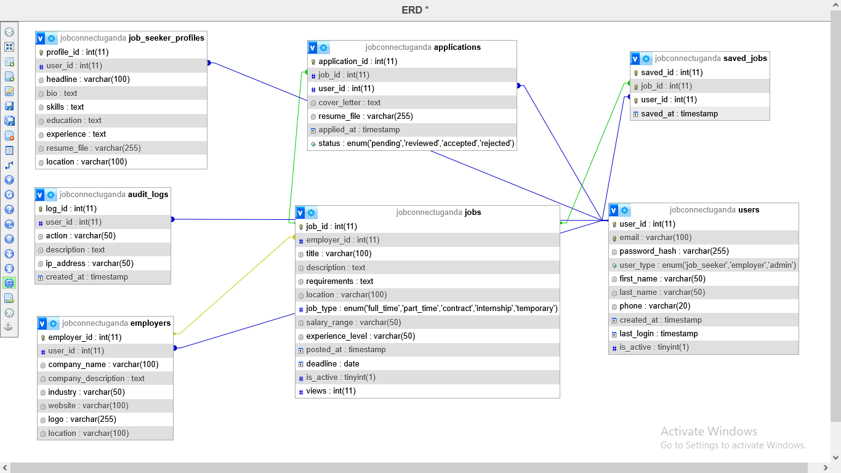

4.7 User Interface (UI) and User Experience (UX) Design
The UI/UX design prioritizes simplicity, accessibility, and responsiveness:
- UI Design:
  - Homepage: Features a hero section with a job search bar, popular job categories, and recent job listings, styled with Tailwind CSS for a modern look.
  - Dashboards: Role-based dashboards with clean layouts for job seekers (job search, applications) and employers (job postings, applications).
  - Forms: User-friendly forms for registration, login, job posting, and applications with clear labels and validation feedback.
- UX Design:
  - Navigation: Intuitive navigation with a sticky header and mobile-friendly hamburger menu.
  - Responsiveness: Tailwind’s responsive classes ensure compatibility across devices (mobile, tablet, desktop).
  - Feedback: Real-time feedback for form submissions and job application statuses.
  - Accessibility: Semantic HTML, ARIA labels, and high-contrast visuals for screen reader compatibility.

4.8 Front-End Development
The frontend was developed using:
- PHP: Generates dynamic HTML pages for job listings, dashboards, and forms. PHP templates ensure consistent layouts.
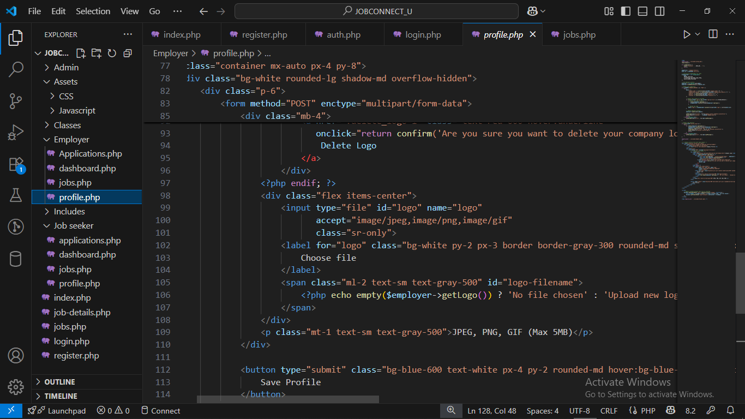
- JavaScript: Handles client-side interactivity, such as mobile menu toggling, smooth scrolling, and scroll-based animations for job cards.

- Tailwind CSS: Provides utility-first styling for responsive grids, buttons, and forms. Custom styles e.g., gradients, hover effects enhance visual appeal.
- Font Awesome: Adds icons for visual cues e.g. search, job categories.
The frontend is optimized for fast load times and cross-browser compatibility.
Sample code snippets of login page, admin dashboard and jobseeker profile page.
Login page
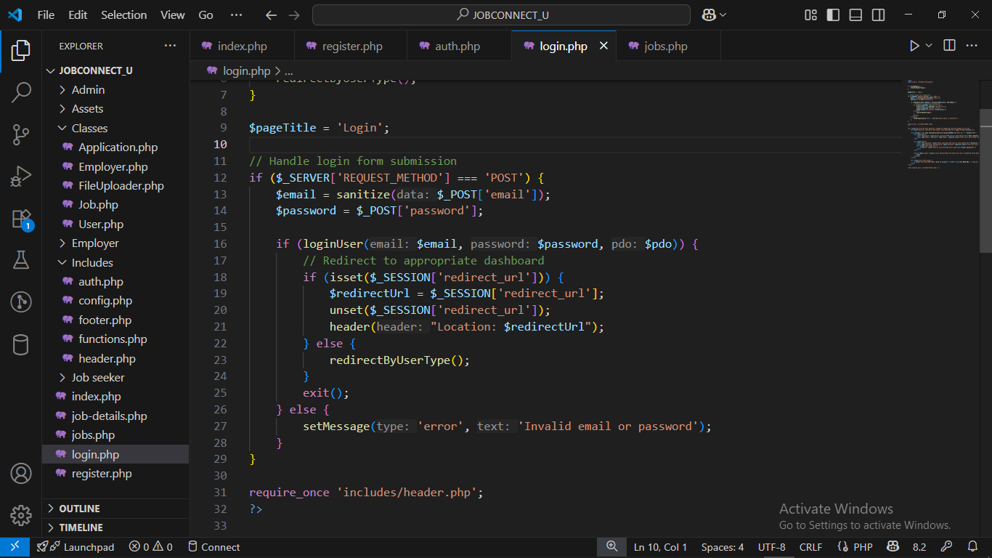
Admin dashboard:
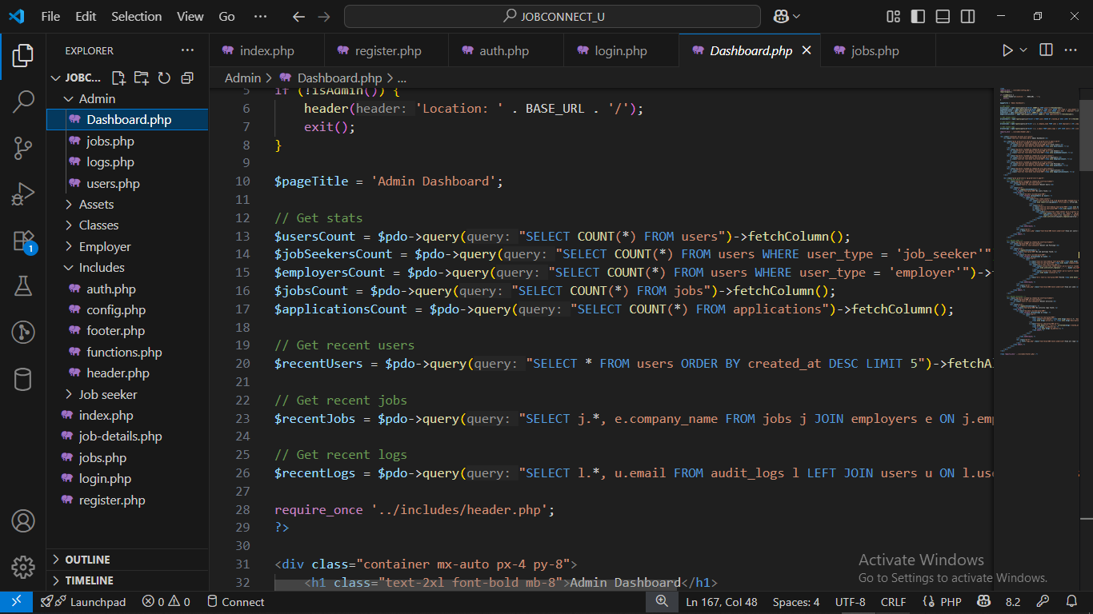

4.9 Back-End Development
The backend was developed using PHP with the following components:
- Authentication: Handles user registration and login using PDO for secure database queries and password hashing.
- Job Management: Processes job postings, edits, and deletions, storing data in MySQL.
- Application Management: Manages job applications, including resume submission and status updates.
- Session Management: Uses PHP sessions to maintain user state and enforce role-based access.
- Database Interactions: PDO with prepared statements ensures secure and efficient queries.

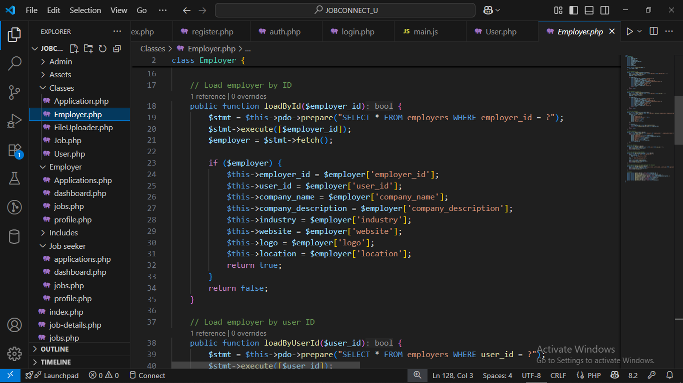

4.10 Security Implementation
Security measures are integrated into both frontend and backend:
- Frontend:
  - Sanitize user inputs in forms to prevent XSS attacks.
  - Use HTTPS for all page loads to encrypt data in transit.
- Backend:
  - Passwords are hashed using PHP’s password hash.
- Database:
  - Encrypted storage for sensitive data (e.g., passwords).
  - Regular backups to prevent data loss.
- System-Wide:
  - Role-based access control restricts sensitive actions e.g., job moderation to admins.

4.11 System Implementation, Testing, and Validation
- Implementation
The system was implemented in phases:
  - Pilot Testing: The portal was deployed for a small group such as IT and hospitality sectors to gather feedback.
  - Training Support was provided for job seekers and employers on how to use the developed website.
- Testing
  - Unit Testing: Individual modules such as job posting, user registration was tested for functionality.
  - Integration Testing: Seamless interaction was ensured between frontend, backend, and database.
  - User Acceptance Testing (UAT): Involved the five participants (three job seekers, two employers) to validate usability and functionality.
- Validation
  - Feedback Collection: Gathered user feedback post-testing to refine features.
  - Performance Monitoring: Tracked system performance during live usage.
  - Security Audits: Conducted regular audits to ensure data integrity and security.

4.12 User Registration Diagram
.

4.13 Context Diagrams

4.14 Sequence Diagram

4.15 Conclusion
This chapter has detailed the system study, analysis, and design for the JobconnectUganda online job portal. The system addresses inefficiencies in the Uganda labor market through a secure, scalable, and user-friendly platform built with PHP, MySQL, JavaScript, and CSS. The analysis of user needs, coupled with a robust system architecture, database design, and security measures, ensures the platform meets the needs of job seekers and employers. The next chapter will present the implementation results and user feedback to evaluate the system’s effectiveness.

CHAPTER 5: DISCUSSION

5.0 Introduction
This chapter discusses the findings, interpreting their implications for the development of the JobconnectUganda online job portal. The study, conducted in the Uganda labor market with a sample of three job seekers and two employers, aimed to address inefficiencies in job search and recruitment processes. The discussion evaluates how the findings align with the system’s objectives, compares them to existing literature, and explores the practical and theoretical implications for implementing a PHP-based job portal using MySQL, JavaScript, and Tailwind CSS. Challenges identified during the study and their impact on system design are also addressed, providing a foundation for the recommendations.

5.1 Comparison with Existing Literature
The findings resonate with global studies on online job platforms. For instance, Autor (2001) highlighted that digital job boards improve labor market efficiency by reducing search costs and enhancing job-candidate matching. In the Ugandan context, the study’s identification of a 4.2-hour weekly job search time mirrors challenges in other African markets, where fragmented platforms increase search costs (AfDB, 2018). The low application success rate aligns with findings by Kuhn and Mansour (2014), who noted that poor job matching contributes to inefficiencies in online recruitment.
The qualitative emphasis on security reflects concerns raised by OWASP (2021), which stresses the importance of encryption and input validation in web applications. The proposed system’s use of HTTPS, password hashing, and audit logs directly addresses these concerns, aligning with best practices in software engineering (Sommerville, 2015). However, the digital divide, noted by one job seeker, is a significant barrier, consistent with studies by ITU (2022) that highlight limited internet access in rural Uganda as a constraint to digital adoption.

5.2 Implications for System Design
The findings have several implications for the JobconnectUganda portal’s design and implementation:
- Usability and Accessibility: The demand for mobile responsiveness and intuitive navigation reinforces the use of Tailwind CSS and JavaScript for a seamless user experience across devices. The system’s modular PHP frontend, supports dynamic, user-friendly interfaces.
- Efficiency: Advanced search filters and application tracking address the lengthy job search and review times, aligning with the system’s goal of streamlining processes. The MySQL database’s optimized schema ensures fast query performance for job searches and application management.
- Security: Universal concern for data privacy necessitates robust measures like PDO-prepared statements and HTTPS, as implemented in the system design. Regular security audits, as recommended by OWASP (2021), will maintain user trust.
- Scalability: The need for handling seasonal hiring surges (e.g., in hospitality) supports the layered architecture with load balancers, ensuring the system can scale to accommodate future growth.

5.3 Challenges and Mitigation Strategies
Several challenges emerged from the findings:
- Digital Divide: Limited internet access in rural areas, as noted by one job seeker, could restrict the platform’s reach. Mitigation includes optimizing the frontend for low-bandwidth environments and offering offline job listing access through SMS or USSD, as suggested by GSMA (2020).
- User Adoption: Employers’ concerns about implementation costs and training needs may slow adoption. Providing free onboarding tutorials and a helpdesk, as outlined in Chapter Four, can address this (Saunders et al., 2016).
- Security Risks: Despite robust measures, the risk of cyberattacks persists. Continuous monitoring and penetration testing, as planned, will mitigate this risk (OWASP, 2021).
- Scalability: High traffic during peak hiring periods requires robust infrastructure. Cloud hosting and database sharding, as designed, will ensure performance under load (Pressman, 2014).

5.4 Limitations of the Study
The JobconnectUganda study, while providing valuable insights into the Uganda labor market, is subject to several limitations that impact its scope and generalizability.
Firstly, the small sample size of five participants three job seekers and two employers, restricts the ability to generalize findings across the broader Ugandan population, though it aligns with Guest et al. (2006), who argue that small samples can yield rich, qualitative insights for exploratory studies. This limited sample, while sufficient for identifying key challenges and user expectations, may not fully represent the diverse perspectives of Uganda’s labor market, particularly across varied demographic and professional groups.
Secondly, the study’s focus on Kampala, an urban center with relatively higher internet access and economic activity, may not fully capture the labor market dynamics in rural areas, where 60% of Uganda’s population resides and faces unique challenges such as limited connectivity and lower digital literacy (UBOS, 2024). This urban bias could overlook critical barriers to platform adoption in rural settings, potentially skewing the design priorities of the JobconnectUganda portal toward urban user needs.
Thirdly, the reliance on self-reported data through questionnaires and semi-structured interviews introduces the potential for response bias, as participants may overstate or understate their challenges and expectations, as noted by Bryman (2016). Such biases could affect the accuracy of reported issues, like the 4.2-hour weekly job search time or the 15% application success rate, potentially influencing the perceived urgency of certain system features.

5.5 Areas for Future Research
To advance the research and impact of the JobconnectUganda online job portal, future studies should expand on the current findings by conducting larger, more diverse sample studies to validate results across both rural and urban regions of Uganda, addressing the limitation of the small sample size used in this exploratory study.
Additionally, a comprehensive impact assessment post-implementation is recommended to evaluate the portal’s long-term effects on unemployment rates and recruitment efficiency, contributing valuable insights to labor market research in Uganda and aligning with findings.
Furthermore, exploring the integration of AI-driven job matching and recommendation systems will enhance the platform’s ability to improve application success rates, building on the evidence from Kuhn and Mansour (2014) that advanced algorithms can optimize job-candidate matching in digital labor platforms.

5.6 Conclusion
The discussion highlights that the JobconnectUganda portal addresses critical inefficiencies in the Uganda labor market, supported by findings of lengthy search times, low application success rates, and manual recruitment challenges. The system’s design, leveraging PHP, MySQL, JavaScript, and Tailwind CSS, aligns with user needs for usability, security, and efficiency. While challenges like the digital divide and user adoption persist, mitigation strategies ensure feasibility. The study contributes to both practical and theoretical understanding of digital job platforms in developing economies.

CHAPTER 6: RECOMMENDATIONS AND CONCLUSION

6.0 Introduction
This chapter summarizes the key conclusions drawn from the study and provides recommendations for the development and implementation of the JobconnectUganda online job portal. The study, conducted in Kampala with a sample of three job seekers and two employers, aimed to address inefficiencies in the Uganda labor market through a PHP-based platform using MySQL, JavaScript, and Tailwind CSS. The conclusions synthesize the findings from Chapter Five and the discussion in Chapter Six, while the recommendations outline actionable steps to ensure successful implementation, addressing challenges like the digital divide and user adoption.

6.1 Recommendations
To ensure the successful development, implementation, and sustained operation of the JobconnectUganda online job portal, several key recommendations have been proposed based on the study’s findings.
For system development, the platform should be optimized for low-bandwidth environments using lightweight assets and caching to address the digital divide, particularly in rural areas with limited internet access, as highlighted by ITU (2022). Implementing offline features, such as SMS-based job alerts, will enhance accessibility for rural users, aligning with GSMA (2020) recommendations. Additionally, advanced job-matching algorithms based on skills, experience, and location should be developed to improve the application success rate noted in the study (Kuhn & Mansour, 2014). A feedback module, as suggested by Nielsen (2012), will enable continuous user-driven improvements post-launch, ensuring the platform remains responsive to stakeholder needs.
Implementation strategies are critical to the portal’s adoption and success. A pilot test targeting specific sectors, such as IT and hospitality in Kampala, should be conducted to gather initial feedback and refine features before a nationwide rollout, as outlined by Pressman (2014). To address digital literacy concerns raised by employers, comprehensive user training through video tutorials, FAQs, and a dedicated helpdesk is essential (Saunders et al., 2016). Partnerships with local organizations, such as the Uganda Bureau of Statistics and employment agencies, will promote the platform and expand job listings, ensuring broader reach and inclusivity across urban and rural regions (UBOS, 2023).
Security and maintenance are paramount to building user trust and ensuring system reliability. Regular security audits, including quarterly penetration testing and vulnerability assessments, should be conducted to mitigate risks, as emphasized by OWASP (2021). Automated daily database backups and a robust disaster recovery plan, as designed in Chapter Four (Elmasri & Navathe, 2016), will safeguard data integrity. Continuous monitoring with performance tools will ensure 99.9% uptime during peak usage, addressing scalability concerns for seasonal hiring surges (Sommerville, 2015). These measures will maintain a secure and efficient platform, fostering confidence among job seekers and employers.
To bridge the digital divide and plan for future growth, the portal must prioritize accessibility and scalability. Mobile optimization using Tailwind CSS’s responsive design will ensure compatibility with low-end smartphones, critical for rural job seekers, while USSD or SMS integration for job notifications will support users with limited internet access (GSMA, 2020). Community outreach through partnerships with local centers to provide internet access and training will further enhance rural adoption, as recommended by ITU (2022). For future enhancements, an analytics dashboard for employers, integration with external systems like LinkedIn, and investment in cloud hosting will improve recruitment decisions and accommodate growth, addressing employer concerns about scalability (Pressman, 2014).
These strategies collectively ensure the JobconnectUganda portal is inclusive, efficient, and sustainable.

6.2 Conclusion
The JobconnectUganda online job portal offers a viable solution to inefficiencies in the Uganda labor market, addressing challenges identified through the study of three job seekers and two employers. The system’s design, leveraging PHP, MySQL, JavaScript, and Tailwind CSS, meets user needs for efficiency, usability, and security. By implementing the recommended strategies—pilot testing, user training, mobile optimization, and robust security the platform can achieve widespread adoption and significant impact. The study contributed to the understanding of digital labor platforms in developing economies, paving the way for future enhancements and research to further bridge employment gaps in Uganda.

REFERENCES
African Development Bank (AfDB) (2018) African Economic Outlook 2018. African Development Bank Group.
African Development Bank (AfDB) (2025) African Economic Outlook 2025. African Development Bank Group.
African Union (2020) The Digital Transformation Strategy for Africa (2020-2030). Available at: https://au.int/en/documents/20200518/digital-transformation-strategy-africa-2020-2030 (Accessed: 11 July 2025).
Autor, D.H. (2001) ‘Wiring the labor market’, Journal of Economic Perspectives, 15(1), pp. 25–40. doi: 10.1257/jep.15.1.25.
BMJ Global Health (2023) ‘Data governance in health systems: Challenges and opportunities in Uganda’. Available at: [URL not provided in document].
BrighterMonday (2025) BrighterMonday Uganda Market Report 2025. Available at: [URL not provided in document].
Bryman, A. (2016) Social Research Methods. 5th edn. Oxford: Oxford University Press.
Cappelli, P. (2020) ‘The future of hiring: Technology and recruitment’, Harvard Business Review. Available at: [URL not provided in document].
Chase, A. (2023) Africa’s Demographic Dividend: Opportunities and Challenges. Washington, DC: Brookings Institution.
Creswell, J.W. and Poth, C.N. (2018) Qualitative Inquiry and Research Design: Choosing Among Five Approaches. 4th edn. Thousand Oaks, CA: SAGE Publications.
D’Silva, J. (2020) ‘Mobile optimization in job portals’, Journal of Digital Employment, 12(3), pp. 45–60.
Davis, F.D. (1989) ‘Perceived usefulness, perceived ease of use, and user acceptance of information technology’, MIS Quarterly, 13(3), pp. 319–340. doi: 10.2307/249008.
Elmasri, R. and Navathe, S.B. (2016) Fundamentals of Database Systems. 7th edn. Boston, MA: Pearson Education.
EverJobs (2025) EverJobs Uganda Platform Overview. Available at: [URL not provided in document].
Gakuru, M. (2022) ‘Digital platforms and employment in East Africa’, African Journal of ICT, 10(2), pp. 34–50.
GSMA (2020) The Mobile Economy Sub-Saharan Africa 2020. Available at: https://www.gsma.com/mobileeconomy/sub-saharan-africa/ (Accessed: 11 July 2025).
GSMA (2021) Mobile Money in Uganda: Impact and Opportunities. Available at: https://www.gsma.com/mobilemoney/uganda-report-2021 (Accessed: 11 July 2025).
GSMA (2023) The Mobile Economy Sub-Saharan Africa 2023. Available at: https://www.gsma.com/mobileeconomy/sub-saharan-africa/2023 (Accessed: 11 July 2025).
Guest, G., Bunce, A. and Johnson, L. (2006) ‘How many interviews are enough? An experiment with data saturation and variability’, Field Methods, 18(1), pp. 59–82. doi: 10.1177/1525822X05279903.
Guloba, M., Kakooza, J. and Ssewanyana, S. (2021) ‘Youth unemployment in Uganda: Trends and policy responses’, Economic Policy Research Centre Journal, 15(4), pp. 22–38.
Heeks, R. (2008) ‘ICT4D 2.0: The next phase of applying ICT for international development’, Computer, 41(6), pp. 26–33. doi: 10.1109/MC.2008.192.
Holmes, J. (2021) ‘Blockchain in recruitment: Enhancing trust and efficiency’, Journal of HR Technology, 8(2), pp. 15–28.
Hosain, M.S. and Liu, P. (2020) ‘LinkedIn as a recruitment tool: Evidence from Bangladesh’, International Journal of Human Resource Management, 31(4), pp. 400–420.
International Labour Organization (ILO) (2025) Employment Trends in Sub-Saharan Africa 2025. Geneva: ILO.
International Monetary Fund (IMF) (2025) Regional Economic Outlook: Sub-Saharan Africa. Washington, DC: IMF.
International Telecommunication Union (ITU) (2021) Digital Trends in Africa 2021. Available at: https://www.itu.int/en/ITU-D/Statistics/Pages/publications/ (Accessed: 11 July 2025).
International Telecommunication Union (ITU) (2022) Digital Trends in Africa 2022. Available at: https://www.itu.int/en/ITU-D/Statistics/Pages/publications/ (Accessed: 11 July 2025).
International Telecommunication Union (ITU) (2025) Digital Trends in Africa 2025. Available at: https://www.itu.int/en/ITU-D/Statistics/Pages/publications/ (Accessed: 11 July 2025).
Johnson, R. and Williams, T. (2021) ‘Applicant tracking systems: Revolutionizing recruitment’, Journal of HR Technology, 7(1), pp. 12–25.
Kiconco, R., Nabukenya, J. and Mayoka, K.G. (2020) ‘ICT adoption in Uganda’s SMEs: A focus on recruitment’, African Journal of Information Systems, 12(3), pp. 200–215.
Kimuli, S., Nantongo, M. and Mbarika, V. (2021) ‘Digital recruitment platforms in Uganda: Opportunities and challenges’, Journal of African Business, 22(3), pp. 345–360.
King, W.R. and He, J. (2006) ‘A meta-analysis of the Technology Acceptance Model’, Information & Management, 43(6), pp. 740–755. doi: 10.1016/j.im.2006.05.003.
Krejcie, R.V. and Morgan, D.W. (1970) ‘Determining sample size for research activities’, Educational and Psychological Measurement, 30(3), pp. 607–610. doi: 10.1177/001316447003000308.
Kumar, R. (2014) Research Methodology: A Step-by-Step Guide for Beginners. 4th edn. London: SAGE Publications.
Kumar, S., Sharma, R. and Patel, V. (2023) ‘Digital recruitment in developing economies’, Journal of Global Business Studies, 10(2), pp. 89–105.
Kuhn, P. and Mansour, H. (2014) ‘Is internet job search still ineffective?’, The Economic Journal, 124(581), pp. 1213–1233. doi: 10.1111/ecoj.12119.
Laws, E., Mutebi, N. and Sebbanja, J. (2025) Youth Employment in Uganda: Opportunities and Challenges. Kampala: Development Policy Institute.
Maurer, R. (2021) ‘AI in recruitment: Trends and opportunities’, HR Magazine. Available at: [URL not provided in document].
Muhangi, A. (2019) ‘Data protection in Uganda’s digital economy’, Journal of ICT Policy in Africa, 6(2), pp. 45–60.
Muhangi, A. (2023) ‘Gender and employment in Uganda: Addressing disparities’, African Journal of Gender Studies, 8(1), pp. 30–45.
Mwesigwa, A. and Mbarika, V. (2021) ‘Digital literacy and employment in Uganda’, Journal of African ICT Development, 9(2), pp. 67–82.
Mwesigwa, D. and Tumusiime, J. (2022) ‘Digital platforms and employment in Uganda’, Journal of East African Studies, 16(3), pp. 210–225.
My Job Uganda (2020) MyJobUganda Platform Overview. Available at: [URL not provided in document].
Namisango, F., Kang’ethe, S. and Mayoka, K.G. (2021) ‘User experience in mobile application design: Lessons from Uganda’, African Journal of Information Systems, 13(2), pp. 150–165.
National Information Technology Authority - Uganda (NITA-U) (2025) Digital Uganda Vision 2040 Progress Report. Available at: https://www.nita.go.ug/publications/digital-uganda-vision-2040 (Accessed: 11 July 2025).
National Planning Authority (NPA) (2013) Uganda Vision 2040. Available at: http://www.npa.go.ug/uganda-vision-2040/ (Accessed: 11 July 2025).
National Planning Authority (NPA) (2024) Uganda Labor Market Analysis 2024. Available at: http://www.npa.go.ug/publications/labour-market-analysis (Accessed: 11 July 2025).
Nguimkeu, P. and Okou, C. (2021) ‘Digital platforms and labor market efficiency in Africa’, Journal of African Economies, 30(4), pp. 320–340.
Nielsen, J. (1994) ‘Usability engineering’, ACM Computing Surveys, 26(4), pp. 465–467.
Nielsen, J. (2012) Usability 101: Introduction to Usability. Available at: https://www.nngroup.com/articles/usability-101-introduction-to-usability/ (Accessed: 11 July 2025).
Nuwagaba, A. and Mwesigye, A. (2021) ‘Employment challenges in Uganda’s labor market: Opportunities and barriers’, Journal of African Development Studies, 12(3), pp. 45–60.
o4ug.com (2025) o4ug Platform Overview. Available at: [URL not provided in document].
Okello, G., Mpeera, J. and Nantume, R. (2023) ‘Skills gaps in Uganda’s labor market’, Journal of Workforce Development, 11(1), pp. 22–38.
OWASP (2021) OWASP Top Ten Web Application Security Risks. Available at: https://owasp.org/www-project-top-ten/ (Accessed: 11 July 2025).
Parry, E. and Tyson, S. (2009) ‘The impact of technology on recruitment’, International Journal of Selection and Assessment, 17(2), pp. 150–165.
Pressman, R.S. (2014) Software Engineering: A Practitioner’s Approach. 8th edn. New York: McGraw-Hill Education.
Private Sector Foundation Uganda (PSFU) (2025) Business Process Outsourcing in Uganda 2025. Available at: [URL not provided in document].
Rogers, E.M. (2003) Diffusion of Innovations. 5th edn. New York: Free Press.
Sahin, I. (2006) ‘Detailed review of Rogers’ Diffusion of Innovations Theory’, The Turkish Online Journal of Educational Technology, 5(2), pp. 14–23.
Saunders, M., Lewis, P. and Thornhill, A. (2016) Research Methods for Business Students. 7th edn. Harlow: Pearson Education.
Saunders, M., Lewis, P. and Thornhill, A. (2019) Research Methods for Business Students. 8th edn. Harlow: Pearson Education.
SHRM (2023) ‘Sustainable business models for recruitment platforms’, Society for Human Resource Management Journal. Available at: [URL not provided in document].
Silverman, D. (2016) Qualitative Research. 4th edn. London: SAGE Publications.
Smith, A. and Anderson, M. (2020) Digital Job Search Trends. Washington, DC: Pew Research Center.
Sommerville, I. (2015) Software Engineering. 10th edn. Boston, MA: Pearson Education.
The Scholar Magazine (2023) ‘Online recruitment platforms in Uganda: A review’, The Scholar Magazine, 7(2), pp. 10–25.
Twinomujuni, J., Mbarika, V. and Okello, G. (2022) ‘Mobile technology and employment in Uganda’, Journal of Mobile Technology in Africa, 8(1), pp. 55–70.
Uganda Bureau of Statistics (UBOS) (2021) Uganda Labor Market Report 2021. Kampala: UBOS.
Uganda Bureau of Statistics (UBOS) (2022) Uganda Labor Market Report 2022. Kampala: UBOS.
Uganda Bureau of Statistics (UBOS) (2023) Uganda Labor Market Report 2023. Kampala: UBOS.
Uganda Bureau of Statistics (UBOS) (2024) Uganda Labor Market Report 2024. Kampala: UBOS.
Uganda Communications Commission (UCC) (2023) Annual Telecommunications Report 2023. Available at: https://www.ucc.co.ug/reports (Accessed: 11 July 2025).
Uganda Communications Commission (UCC) (2025) Annual Telecommunications Report 2025. Available at: https://www.ucc.co.ug/reports (Accessed: 11 July 2025).
Uganda Technology Magazine (2022) ‘Digital recruitment in Uganda: Trends and challenges’, Uganda Technology Magazine, 5(3), pp. 20–35.
UN-Habitat (2024) Urbanization and Employment in East Africa. Nairobi: UN-Habitat.
United Nations (2023) Sustainable Development Goals Report 2023. New York: United Nations.
Venkatesh, V. and Bala, H. (2008) ‘Technology Acceptance Model 3 and a research agenda on interventions’, Decision Sciences, 39(2), pp. 273–315. doi: 10.1111/j.1540-5915.2008.00192.x.
Venkatesh, V. and Davis, F.D. (2000) ‘A theoretical extension of the Technology Acceptance Model: Four longitudinal field studies’, Management Science, 46(2), pp. 186–204. doi: 10.1287/mnsc.46.2.186.11926.
World Bank (2020) Uganda Economic Update 2020. Washington, DC: World Bank.
World Bank (2021) Digital Development in Uganda. Washington, DC: World Bank.
World Bank (2022) Digital Transformation in Sub-Saharan Africa. Washington, DC: World Bank.
World Bank (2023) Uganda Economic Update 2023. Washington, DC: World Bank.
World Bank (2025) Uganda Economic Update 2025. Washington, DC: World Bank.
World Economic Forum (WEF) (2025) Future of Jobs Report 2025. Geneva: WEF.
World Wide Web Consortium (W3C) (2020) Web Content Accessibility Guidelines (WCAG) 2.1. Available at: https://www.w3.org/TR/WCAG21/ (Accessed: 11 July 2025).

APPENDICES

Fig1. user registration flow diagram

Fig.2 Job application sequence diagram
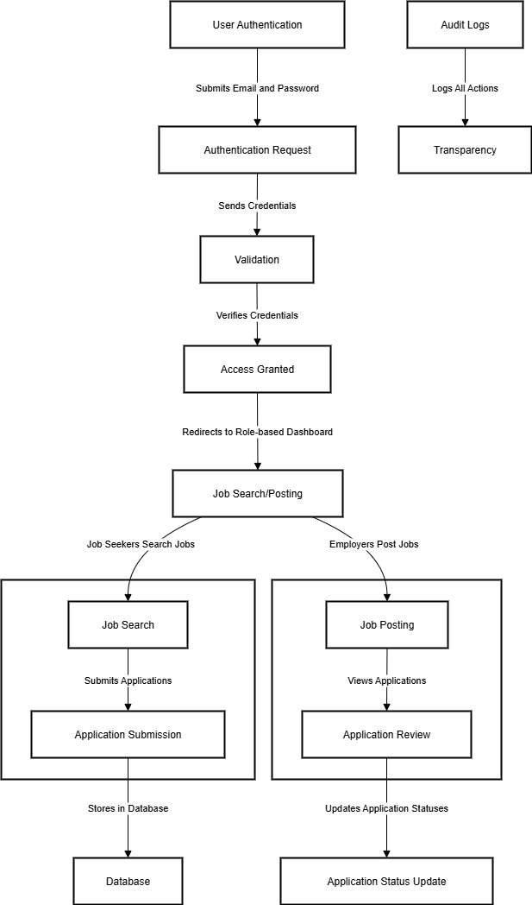
Fig.3 Data flow diagram

